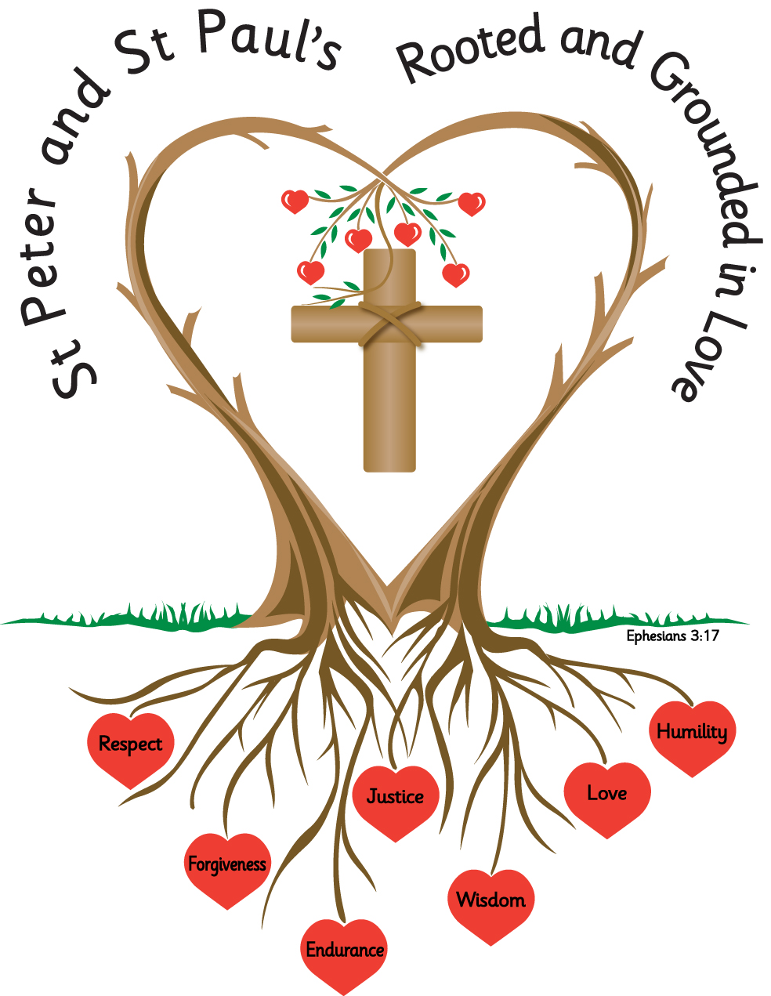
Name: _______________________ Year: 3

Homework
Summer 2 2027

Year 3 Homework – Summer Term 2

Please complete the task set each week and hand your homework booklet on the last week of term.
Please note that children should continue to read daily to an adult, with reading records being signed and books and reading records returned to school.
All children have a TT Rockstars password and this should also be accessed weekly.

Week 1
Using a thesaurus look up these words and provide five different synonyms for each one;
Example; Laugh – giggle, cackle, snigger, howl, roar.

sad
kind
big
funny
cold

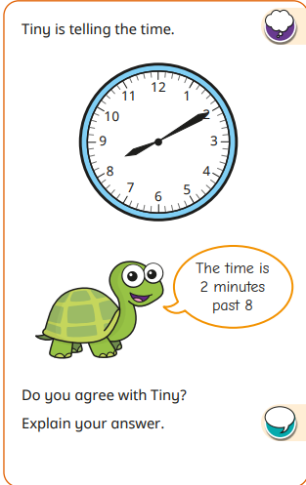
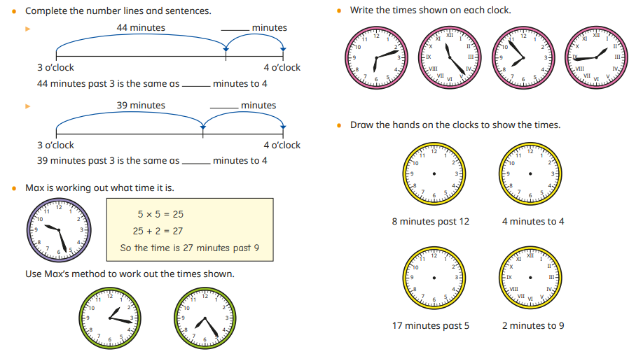

Week 2
Looking at homophones and near homophone, practice spelling these homophones;
ball bawl source sauce peace piece ate eight
grown groan bury berry meet meat male mail
through threw break brake poor pour hour our

For the next few weeks, we will be revising some of the grammar that we have learned in Year 3.
Think about what we have learnt about when to use ‘a’ and ‘an’.
Write 3 of your own sentences using ‘a’ or ‘an’ correctly
____________________________________________________________________________________________________________________________________________________________________________________________________________________________________________________________________
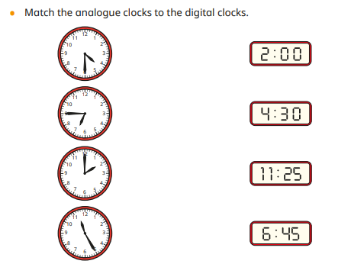
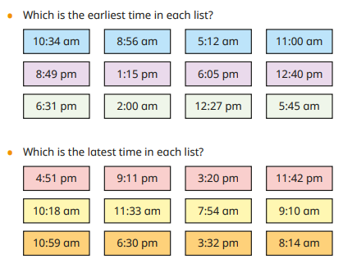
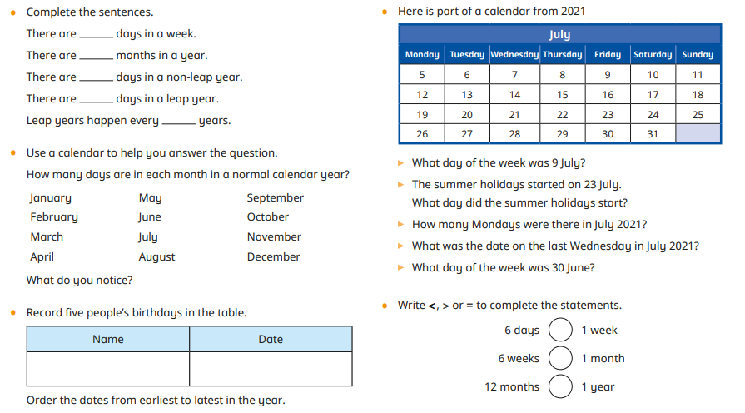
Week 3
Practice spelling these irregual plurals
mouse mice
die dice
louse lice
child children
person people
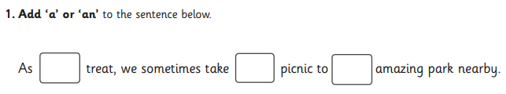
penny pence

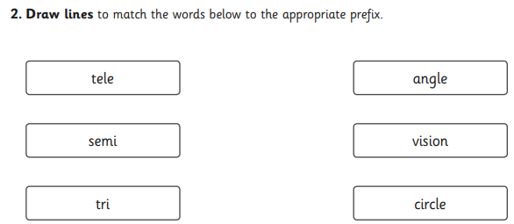

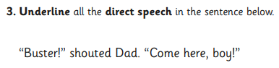

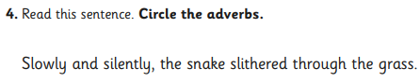

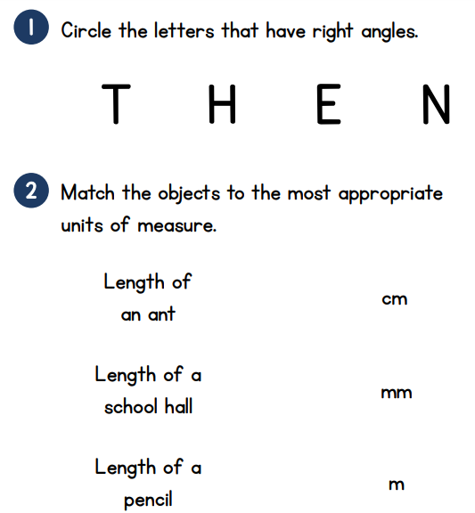

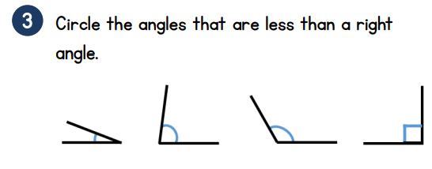

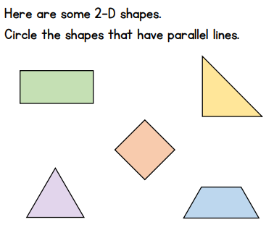
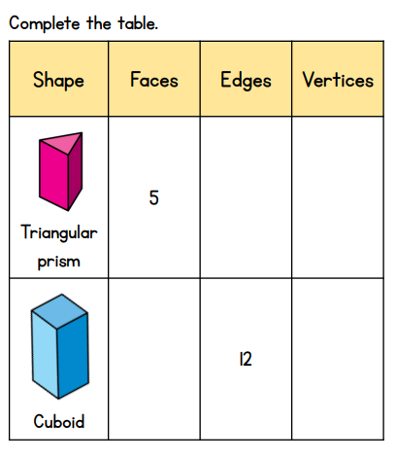
Week 4
Suffix -ly, -ous
Practice spelling these words; using look, say, copy, cover (write without looking).
beautifully
strangly
gently
colourfully
lazily
silently
dangerous
couragous
humourous
adventurous
poisonous
enormous

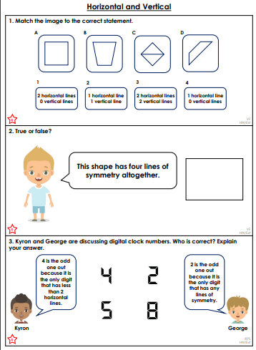
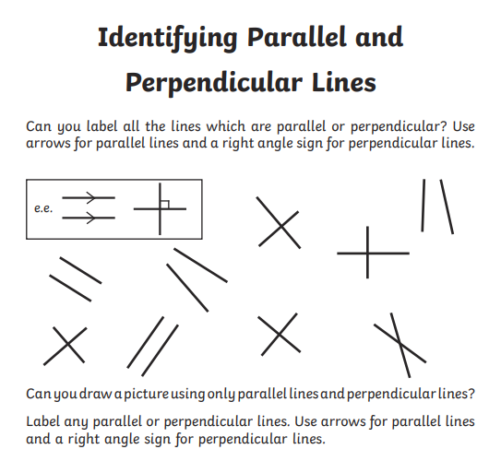

Week 5
Word Families – sort the words into the correct word family. There are 3 families.
tricycle medical paramedic triangle trio prescribe medicine prevent triplet prepare medicinal predict
medic triathlon preview

1 | 2 | 3

1.
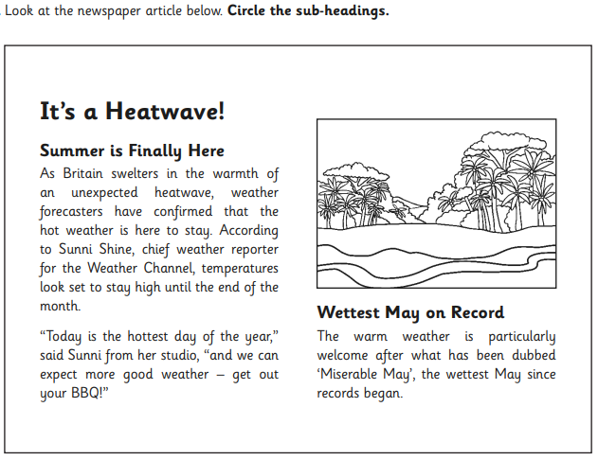
2.
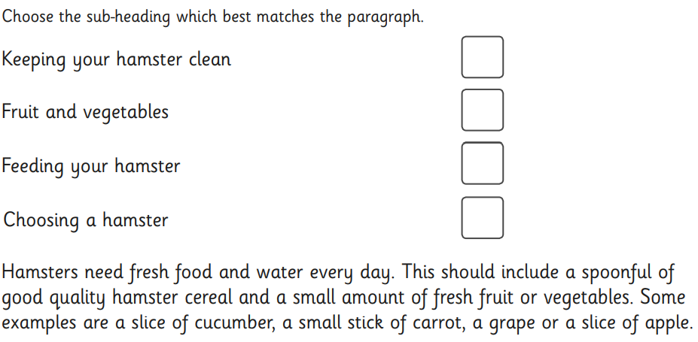
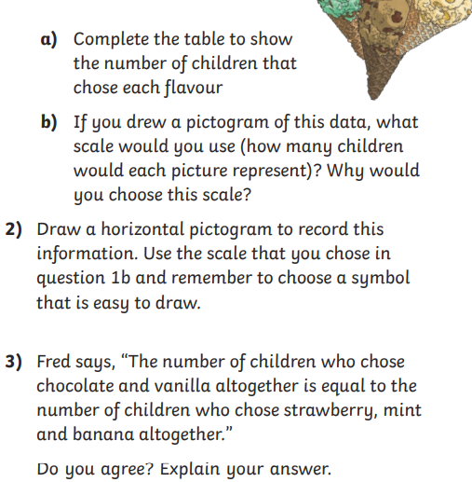
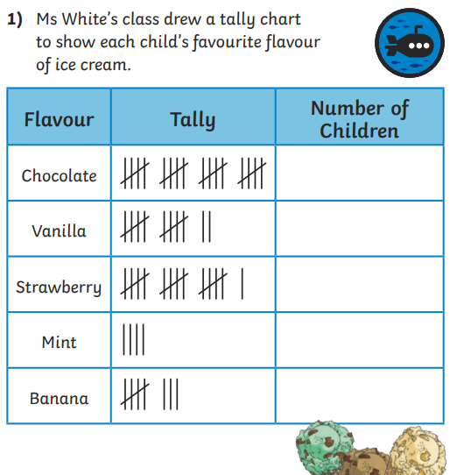

Week 6
Revision – spelling rules we have learned in Stage 3.

Week 6
Recap on some words and rules from this half term with some frequently misspelt words.

ball
sauce
through
children
person
people
beautifully
adventurous
enormous
medical
prepare
triangle
predict
could
saw
said
want

1.
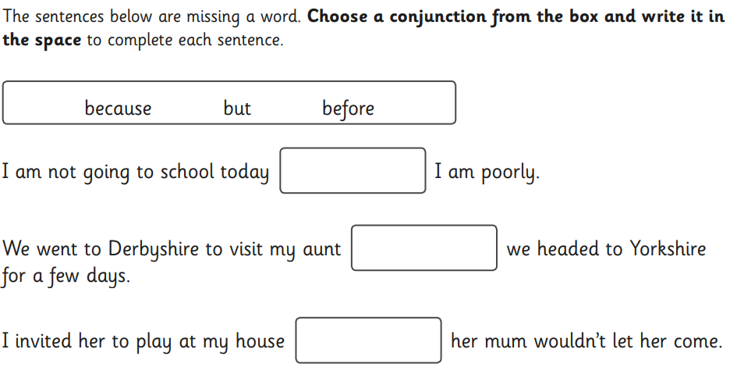

2.
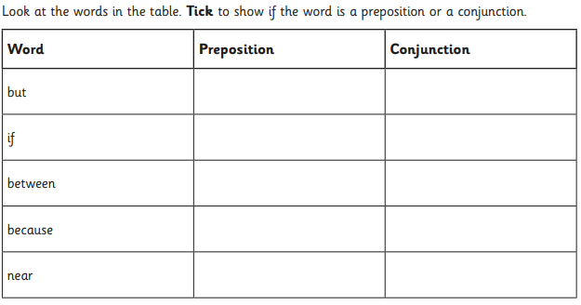
3.
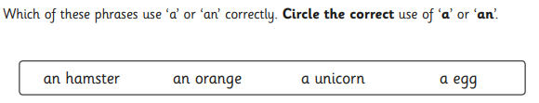.
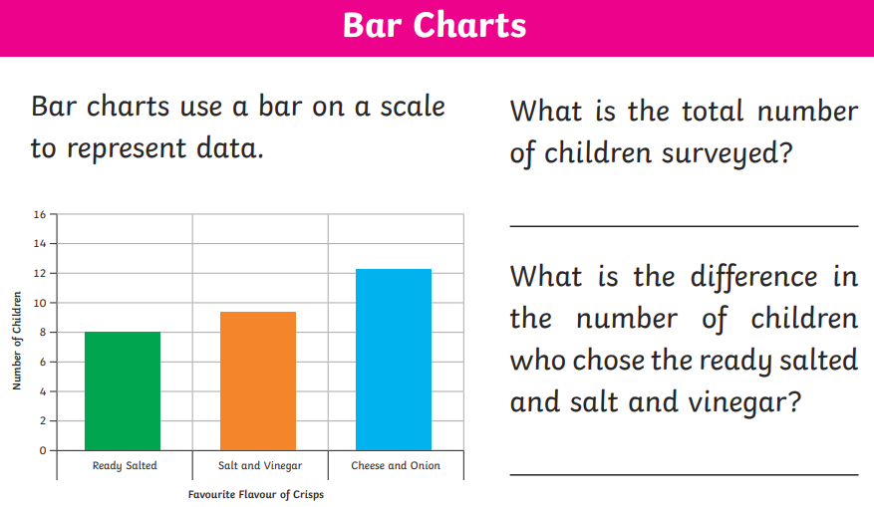
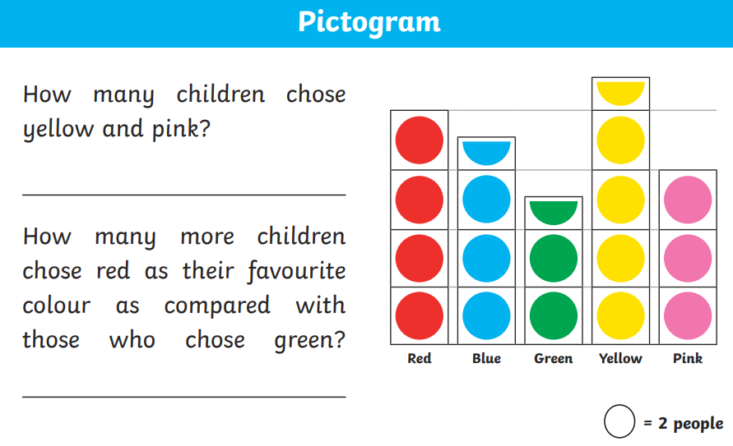

Task:
Please complete the two reading comprehensions.

- Charlotte’s Web – Wilbur Escapes

Text (Adapted)

One bright morning, Wilbur pushed his nose against the loose board in the fence. It wobbled. He pushed again, harder this time, and suddenly—crack!—the board came free.

Wilbur squeezed through the gap and found himself outside. The grass looked greener than ever before. The air smelled fresh and exciting.

“I’m free!” Wilbur cried, running across the yard.

The other animals watched him. The goose called out, “Run, run! Make the most of it!”

Wilbur dashed this way and that, kicking up his heels with delight. But soon, he began to feel tired. Running was harder than he had expected.

The farmer came hurrying across the yard with a bucket of warm milk. He called Wilbur in a calm voice.

At once, Wilbur stopped. The smell of the milk drifted towards him. Slowly, he followed the farmer back into the yard.

Soon he was safely back in his pen, slurping happily.

Questions

Vocabulary (2a)

1. What does “dashed” mean? (1 mark)
☐ Walked slowly
☐ Ran quickly
☐ Sat down
☐ Looked around

2. Find and copy one word that shows Wilbur was excited. (1 mark)

Retrieval (2b)

3. How did Wilbur escape? (1 mark)

4. What did the farmer carry? (1 mark)

5. What did Wilbur smell? (1 mark)

Sequencing (2c)

6. Number these events (1–4). (2 marks)

___ Wilbur runs around the yard
___ The farmer calls Wilbur
___ Wilbur escapes through the fence
___ Wilbur returns to his pen

7. What is the main idea of this text? (1 mark)

Inference (2d)

8. Why did Wilbur stop running? (2 marks)

9. Why did Wilbur go back to the pen? (2 marks)

Language (2g)

10. “The grass looked greener than ever.”
What does this tell us about how Wilbur feels? (2 marks)

11. Why does the author describe Wilbur “kicking up his heels”? (2 marks)

Prediction (2e)

12. What do you think Wilbur has learned from this experience? (3 marks)

Character (extended)

13. Do you think Wilbur enjoys being free or being looked after?
Explain using evidence. (4 marks)

- Charlotte’s Web – The Fair

Text (Adapted)

The fair was busy and full of noise. People walked past in groups, laughing and talking. Bright lights shone from every stall.

Wilbur lay quietly in his pen, feeling nervous. He had never been anywhere like this before.

Charlotte sat above him, watching everything carefully.

“You must stay calm,” she said. “You are special.”

Wilbur listened closely. He wanted to believe her, but his legs felt shaky.

Nearby, another pig snorted loudly. It looked bigger and stronger than Wilbur.

Wilbur gulped. “What if I’m not good enough?” he whispered.

Charlotte did not answer straight away. Then she said, “You are more than enough.”

Wilbur took a deep breath and stood a little taller.

Questions

Vocabulary (2a)

1. What does “nervous” mean? (1 mark)
☐ Calm
☐ Worried
☐ Excited
☐ Angry

2. Find and copy one word that shows Wilbur is unsure. (1 mark)

Retrieval (2b)

3. Where is Wilbur? (1 mark)

4. Who is with Wilbur? (1 mark)

5. What is the fair like? Give one detail. (1 mark)

Sequencing (2c)

6. Put these events in order. (2 marks)

___ Wilbur sees another pig
___ Charlotte tells him he is special
___ Wilbur feels nervous
___ Wilbur stands taller

7. What is the main idea? (1 mark)

Inference (2d)

8. Why does Wilbur feel nervous? (2 marks)

9. How does Charlotte help Wilbur? (2 marks)

Language (2g)

10. “His legs felt shaky.”
What does this tell us about Wilbur? (2 marks)

11. Why does the author describe the fair as “busy and full of noise”? (2 marks)

Prediction (2e)

12. What do you think will happen at the fair? (3 marks)

Character (extended)

13. How does Wilbur change during this text?
Use evidence. (4 marks)

