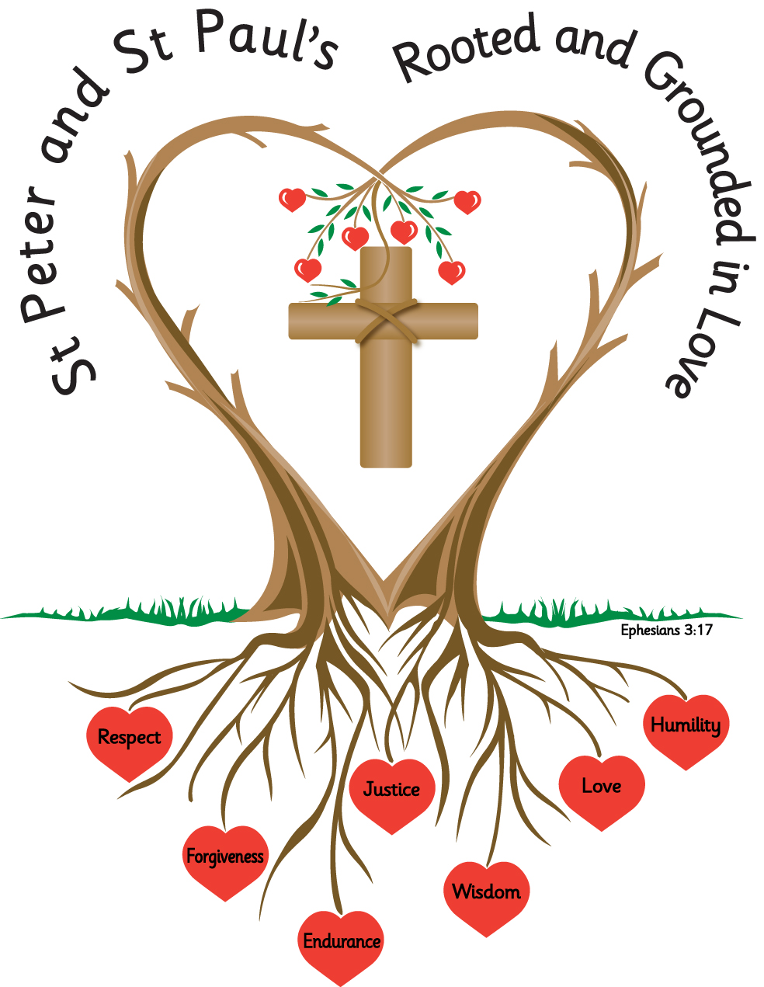
Name: _______________________ Year: 3

Homework
Summer 1 2027

Year 3 Homework – Summer Term 1
Please complete the task set each week and hand your homework booklet in on the last week of term.
Included at the end of the booklet are two reading comprehensions, that the children should work through over the half term.
Please note that children should continue to read daily to an adult, with reading records being signed and books and reading records returned to school.
All children have a TT Rockstars password, and this should also be accessed weekly.

Week 1
Use the first two letters of a word to check its spelling and meaning in a dictionary.
Pick 3 words from the spelling list, below. Use a dictionary to find the word, remember to use the first two letters to find the word then write the definition for each word.
____________________________________________________________________________________________________________________________________________________________________________________________________________________________________________________________________________________________________________________________________________________________________________________________

young
country
can’t
wouldn’t
weight
wait
child
children
furious
various
leisure
treasure

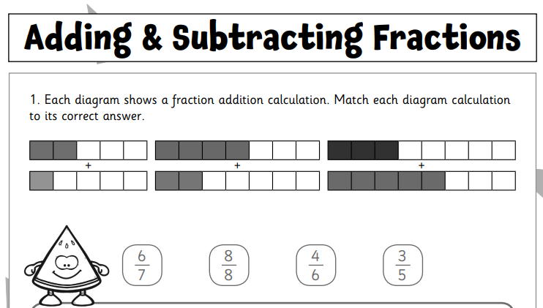
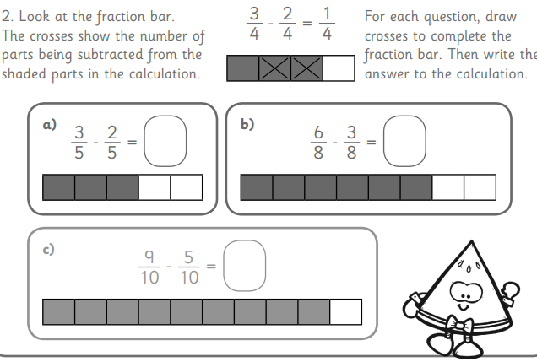
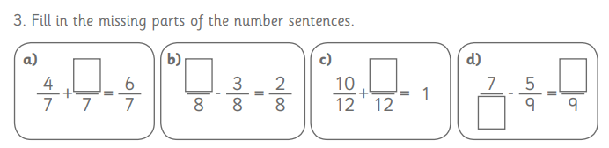

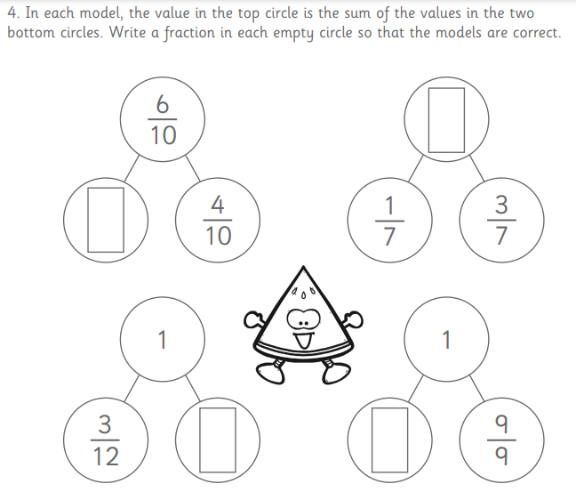

Week 2
Spell correctly and distinguish between the homophones, ball/bawl, sauce/source, peace/piece, meddle/medal, who's/whose
Fill in the blanks using the correct homophone;

ball bawl meddle medal who's whose
---------------------------------------------------------
Tennis uses a lightweight yellow ____.
____ ready for our new history topic?
Don't _____ with your father's car keys!
The naughty child began to ____ loudly on purpose.
She was the only child to achieve the St. Mary's _____.
_____ question should we answer first?

Challenge
Write 5 sentences that include an adverb.
____________________________________________________________________________________________________________________________________________________________________________________________________________________________________________________________________________________________________________________________________________________________________________________________
____________________________________________________________________________________________________________________________________________________________________________________________________________________________________
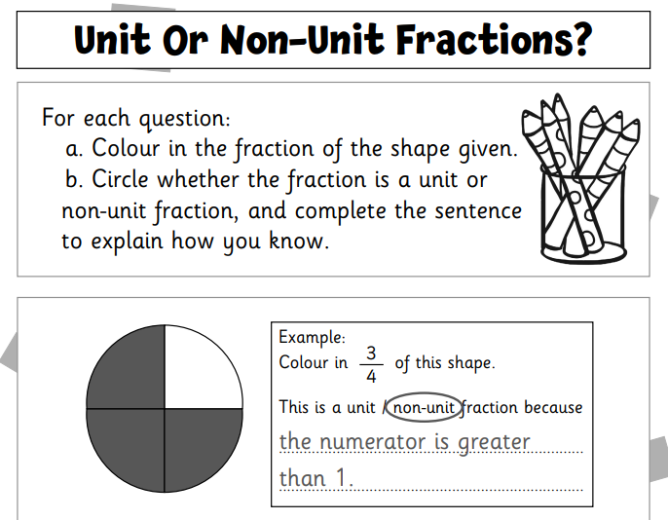
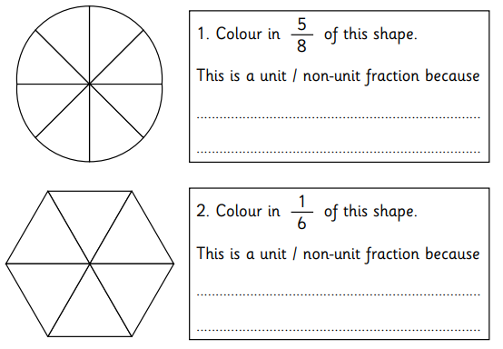
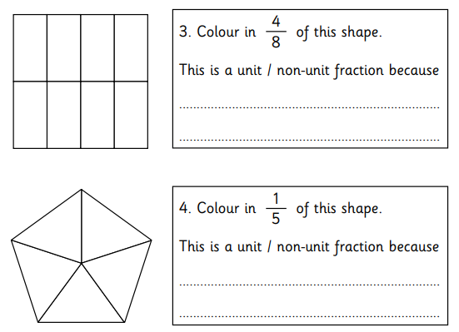

Week 3
Identify and spell irregular past tense verbs, e.g.
catch, caught; know, knew; shine, shone.

Draw a line to match each present tense verb with its past tense form;
catch shone
know caught
shine knew

Fill in the blanks
Choose the correct past tense verb from the list above to complete each sentence;
- Yesterday, I __________ the ball at play time.
- The sun ____________ brightly in the sky.
- I ______________ The answer to the question!
Write your own sentence using one of the past tense verbs above.

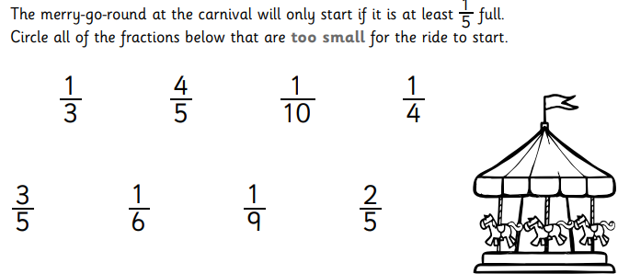

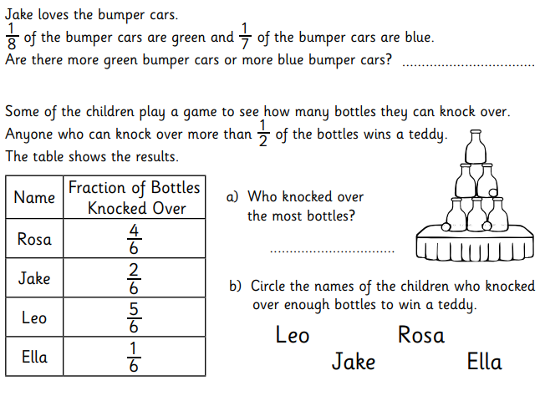
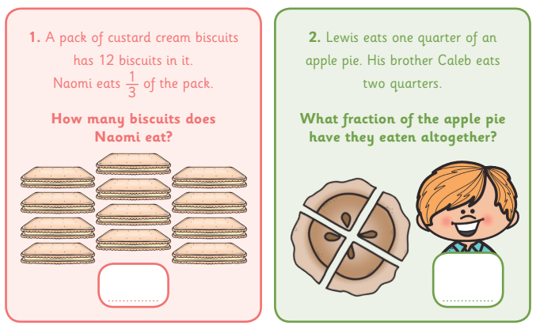
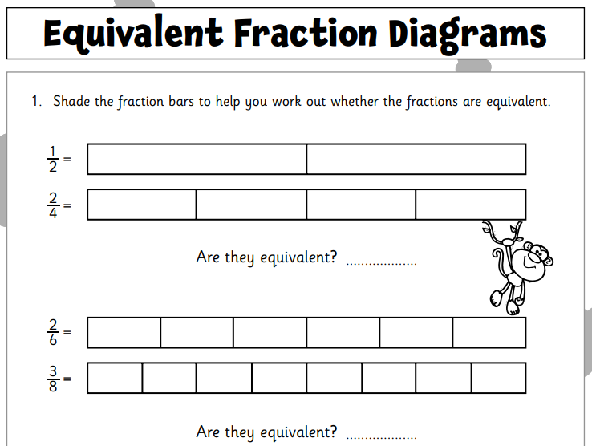

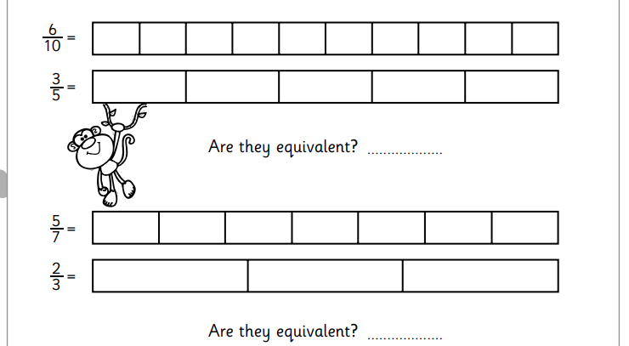

Week 4
Add the prefixes re-, mis- and dis-, e.g. redecorate, misunderstand, disappointed.

replay
recycle
redecorate
rehydrate
recalculate
remarry
misplace
misprint
mistreat
disappoint
disapprove
disappear

dishonest
re – means again
mis – means wrongly
dis – means not or the opposite of

Draw a line to match each present tense verb with its past tense form;
replay to not tell the truth
mistreat to play again
dishonest to treat someone badly
redecorate to decorate again
misplace to no longer be seen
disappear to put something in the wrong place

Choose three words from week 4 spelling list, write your own sentence for each of the three words.
___________________________________________________________________________________________________________________________________________________________________________________________________________________________________________________________________________________________________________________________________________________________________________________________________________________________________________________

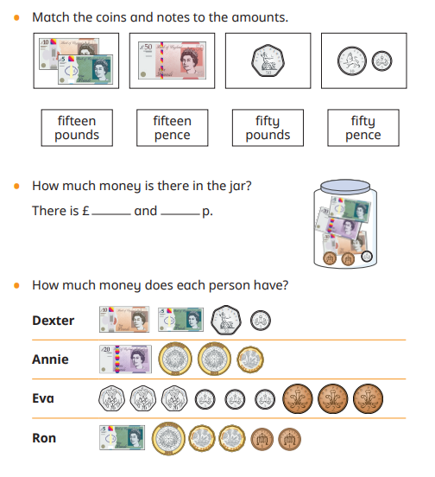
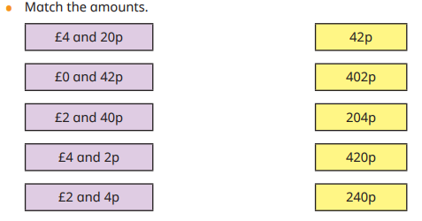
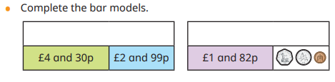
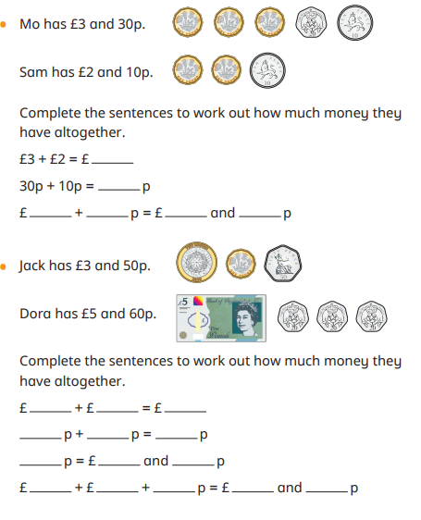

Week 5
Words with endings sounding like /tʃə/ spelt -ture, e.g. agriculture, miniature.

adventure
departure
temperature
miniature
furniture
agriculture
literature
puncture
manufacture
future
mixture

In the table below, for each word, trace over the word, then write the word, then cover and write the word and finally write the word with your eyes closed.
Trace  adventure  temperature  puncture  mixture  furniture | write
Cover and write | Write with your eyes closed

Challenge
Write a sentence that includes a subordinate clause.
____________________________________________________________________________________________________________________________________________________________________________________________________________________________________________________________________________________________________________________________________________________________________________________________
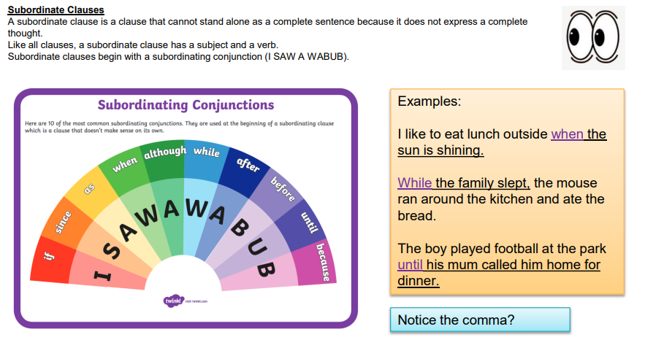

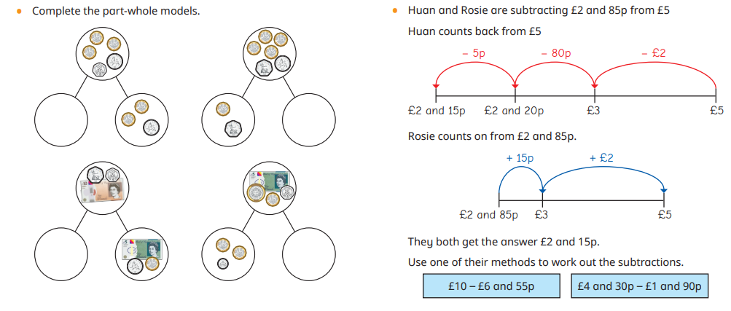
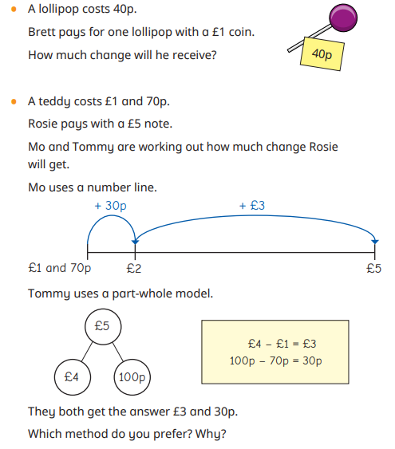
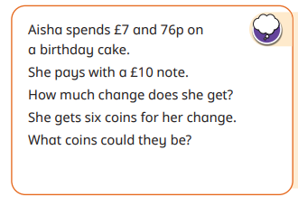

Week 6
Use apostrophes to spell words using the contracted form and for singular possession
e.g., haven’t, they’ve, Mr Hall’s

Contractions
Write the full form of these contractions:
- doesn’t = _________________________
- isn’t = _________________________
- wasn’t = _________________________
- weren’t = _________________________
- let’s = _________________________
- should’ve = _________________________
- you’ve = _________________________
- haven’t = _________________________
- they’ve = _________________________

Singular Possession
Possession mean that something belongs to the person.
Look at the sentence and underline the thing that belongs to the person.
Example: Mr Hall’s car is red.
(The car belongs to Mr Hall.)
- Mr Hall’s classroom is very tidy.
- The child’s toy was missing.
- Philip’s book is on the table.

Now, write one sentence of your own for each word below. Make sure you show what belongs to the person:
- Mr Hall’s ____________________________
- child’s ____________________________
- Philip’s ____________________________

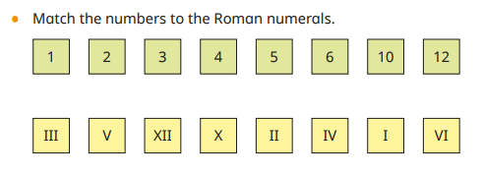
Match the Roman Numerals
Draw a line to match each Roman numeral to the correct number:
Roman Numeral | Number
I | 5
II | 1
III | 10
IV | 6
V | 3
VI | 4
VII | 2
VIII | 12
IX | 7
X | 11
XI | 9
XII | 8

Fill in the Blanks

Write the Roman numeral for each number:

- 1 = ______
- 4 = ______
- 7 = ______
- 10 = ______
- 12 = ______

Write the number for each Roman numeral:
- VI = ______
- III = ______
- IX = ______
- XI = ______
- VIII = ______

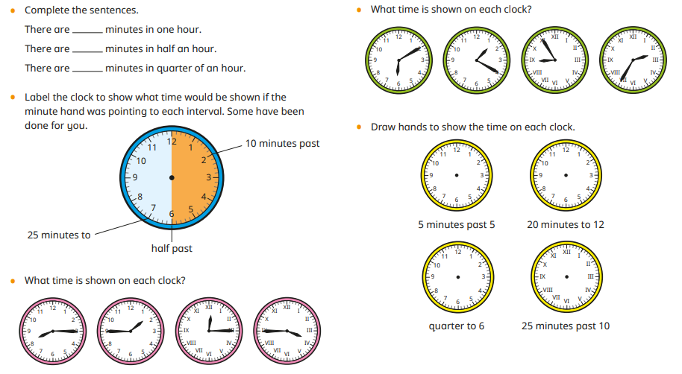

Task:
Please complete the two reading comprehensions.

- Charlotte’s Web – A New Friend

Read the text carefully, then answer the questions.

Charlotte’s Web – A New Friend (Adapted)

Wilbur the pig did not feel very important. He was smaller than the other animals and often felt lonely in the barn. During the day, the cows chatted among themselves and the sheep stayed close together in their woolly groups. Wilbur sometimes tried to join in, but no one paid him much attention.

One quiet evening, as the barn grew dark, Wilbur heard a small voice.

“Do you want a friend?” it asked.

Wilbur jumped. He looked around but could not see anyone. The barn was still and silent.

“I will be your friend,” the voice continued kindly. “I have been watching you all day.”

Wilbur felt a warm glow inside his chest. Someone had noticed him! “Who are you?” he asked nervously.

“Up here,” said the voice.

Wilbur tilted his head and saw, high in the corner of the barn, a large grey spider sitting in her web. The web shimmered in the moonlight, each thread carefully woven.

“My name is Charlotte,” said the spider calmly.

Wilbur had never spoken to a spider before. At first, he felt frightened. Spiders were not the sort of friends he had imagined. But Charlotte’s voice was gentle, and her words were thoughtful.

Before long, Wilbur realised he was no longer afraid. He began to feel hopeful instead. Perhaps life in the barn would not be so lonely after all.

Questions

Vocabulary (2a)

1. What does the word “lonely” mean in this text? Tick one. (1 mark)
☐ Angry
☐ Alone and sad
☐ Sleepy
☐ Excited

2. Find and copy one word that shows Charlotte is kind. (1 mark)

Retrieval (2b)

3. Where was Charlotte sitting? (1 mark)

4. What did Wilbur hear at the beginning of the evening? (1 mark)

5. Give one reason why Wilbur felt unimportant. (1 mark)

Sequencing / Summarising (2c)

6. Number these events from 1–4 in the order they happen. (2 marks)

___ Wilbur sees Charlotte in her web.
___ Wilbur hears a voice.
___ Charlotte offers to be his friend.
___ Wilbur feels hopeful.

7. What is this part of the story mostly about? (1 mark)

Inference (2d)

8. Why do you think Wilbur “jumped” when he heard the voice? (2 marks)

9. How do we know Wilbur begins to trust Charlotte?
Give one piece of evidence from the text. (2 marks)

10. How do Wilbur’s feelings change during the text? (2 marks)
At the beginning he feels: __________________________
At the end he feels: __________________________

Language (2g)

11. The text says the web “shimmered in the moonlight.”
What picture does this create in your mind? (2 marks)

12. Why does the author describe Charlotte’s voice as “gentle”?
What does this tell us about her character? (2 marks)

Prediction (2e)

13. What do you think will happen next in the story?
Use clues from the text to explain your answer. (3 marks)

- Charlotte’s Web – The Egg Sac

Read the text carefully and answer the questions.

The Egg Sac (Adapted)

Late one evening, the barn was quiet and still. Wilbur lay in the straw thinking about Charlotte. The summer was nearly over, and the air felt cooler than before.

High above him in the doorway, Charlotte was busy spinning silk. Her long legs moved quickly and carefully as she worked.

“What are you doing?” Wilbur called up.

“I am making something important,” Charlotte replied calmly.

Wilbur watched with great curiosity. Charlotte was spinning a round, white ball made from strong silk. She worked slowly and carefully, wrapping the threads around it again and again.

“That is my egg sac,” Charlotte explained. “Inside it are my eggs.”

Wilbur felt amazed. “How many eggs are there?” he asked.

“Oh, quite a few,” said Charlotte. “Perhaps five hundred.”

Wilbur’s eyes grew wide with surprise. Five hundred! He could hardly imagine such a number.

Charlotte finished tying the silky threads. The egg sac hung safely in the corner of the barn, shining softly in the evening light.

Wilbur felt proud of his friend. He knew the tiny spiders inside the sac would one day hatch and fill the barn with new life.

Questions

Vocabulary (2a)

1. What does the word “curiosity” mean in this sentence? (1 mark)

☐ Anger
☐ Wanting to know something
☐ Feeling sleepy
☐ Feeling hungry

2. Find and copy one word that shows Charlotte worked carefully. (1 mark)

Retrieval (2b)

3. Where was Wilbur lying? (1 mark)

4. What was Charlotte making? (1 mark)

5. About how many eggs were inside the egg sac? (1 mark)

Sequencing / Summarising (2c)

6. Number these events from 1–4 in the order they happen. (2 marks)

___ Charlotte explains about the eggs
___ Wilbur watches Charlotte spinning silk
___ Charlotte finishes the egg sac
___ Wilbur asks what she is doing

7. What is the main idea of this part of the story? (1 mark)

Inference (2d)

8. Why do you think Wilbur’s eyes “grew wide with surprise”? (2 marks)

9. How do we know Wilbur cares about Charlotte?
Give one piece of evidence from the text. (2 marks)

Language (2g)

10. The text says the egg sac was “shining softly in the evening light.”
What picture does this create in your mind? (2 marks)

11. Why does the author describe Charlotte’s legs moving “quickly and carefully”? (2 marks)

Prediction (2e)

12. What do you think will happen when the eggs hatch?
Explain your answer using clues from the text. (3 marks)

Character Understanding

13. How does Wilbur feel about Charlotte in this part of the story?
Use evidence from the text. (4 marks)

