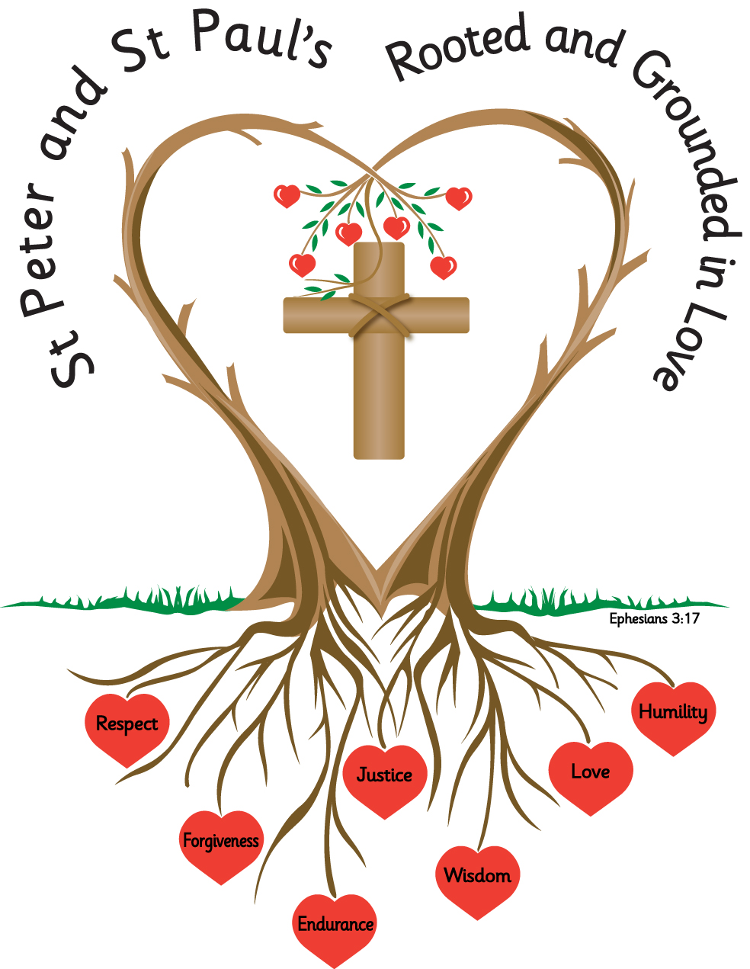
Name: _______________________ Year: 3

Homework
Spring 2 2027

Year 3 Homework - Spring Term 2
Please complete the task set each week and hand your homework booklet in on the last week of term.
Please note that children should continue to read daily to an adult, with reading records being signed and books and reading records returned to school.
All children have a TT Rockstars password and this should also be accessed weekly.

Week 1
words containing the /ʌ/ sound spelt ou, e.g. double, country, enough
Choose four words from this weeks spelling list and write four sentences with one of the words in each sentence.
young cousin southern country courage trouble double enough double country touch encourage southern

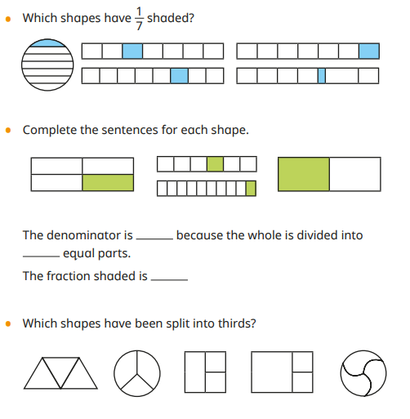
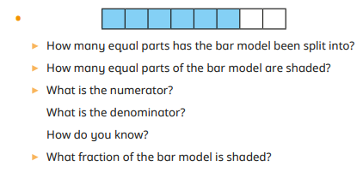
Week 2
Spellings
words with contracted forms, e.g. they'd (they would/they had) it's (it is).
Write the contracted form of these words;
they would – they’d
could not
should not
would not
could have
should have
would have
I would
She would
He would

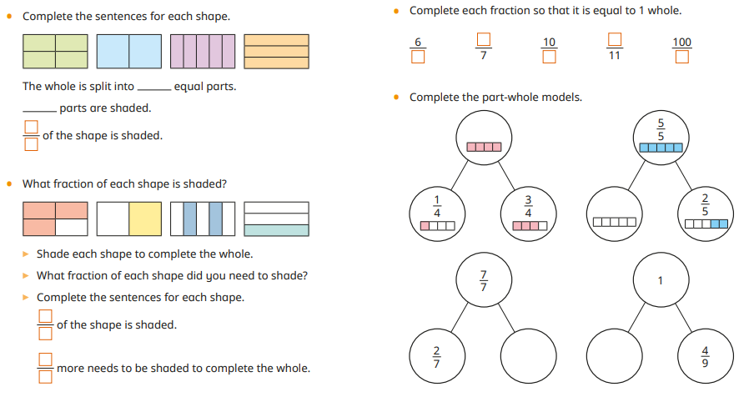

Week 3
Spelling
Spell correctly and distinguish between the homophones
Choose the correct homophone;
ate eight wait weight
There were only ______ children in the class.
You'll just have to ______ and see.
You must enter your height and _______ on the form.
She will be ______ years old on her next birthday.
We ______ our lunch in the city centre.
The woman couldn't believe the ______ of the books.
They _____ their meal while deep in thought.
Where should I ______?
There were _______ bicycles in total.
Actually, I can't _____ for him to arrive home.

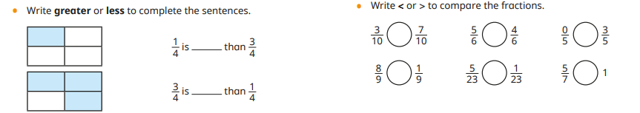
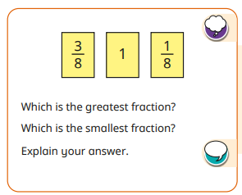
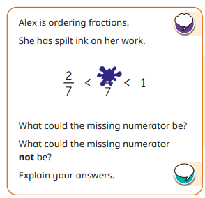

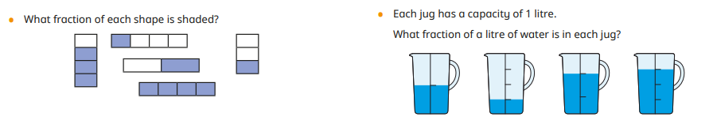

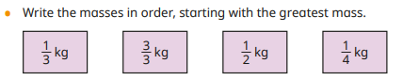

Week 4
Spelling
Identify and spell irregular plurals, e.g. tooth, teeth; woman, women; sheep, sheep.

Fill in the blanks with the correct irregular plural;

foot feet tooth teeth woman women
person people sheep goose geese

I must brush my _____ twice a day.
Jack climbed the beanstalk and found a golden _____.
Boudicca was a very determined and powerful _____.
There were hundreds of ______ at the concert.
I must get my ______ measured before choosing new shoes.
The farmer shears his ______ before the warmer weather.

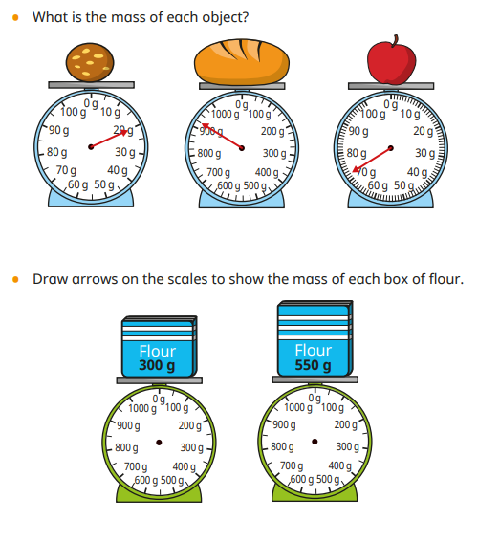

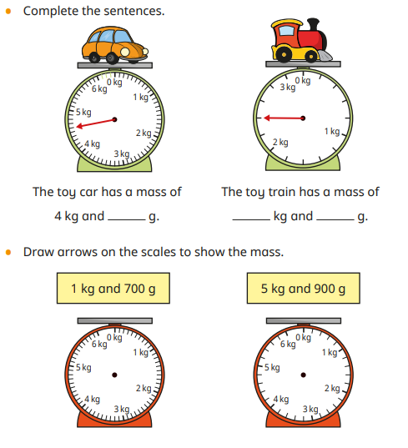

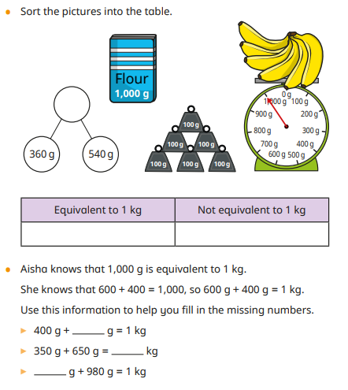

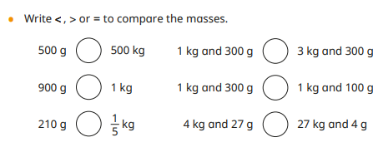

Week 5
Spelling
Add the suffix -ous e.g. humorous, courageous, serious.

Choose four words from the spelling list and create four different sentences using one of the words in each sentence.
enormous fabulous generous numerous ravenous serious nervous jealous adventurous

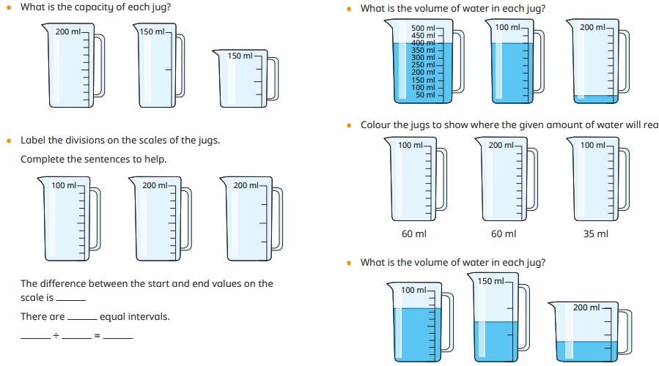

Week 6
Spelling
Practice your spellings

Spelling | Attempt 1 | Attempt 2 | Attempt 3 | Attempt 4 | Attempt 5
measure

enclosure

leisure

pleasure

treasure

closure

composure

pressure
exposure

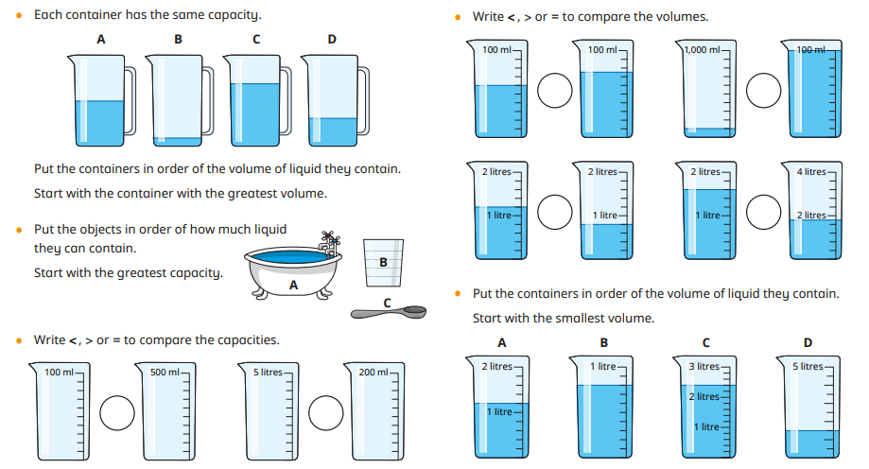
Task:
Complete the two reading comprehensions

The Worst Witch – The Midnight Cat

Based on The Worst Witch by Jill Murphy

Read the text carefully and answer the questions.

The Midnight Cat (Adapted)

The castle corridors were dark and silent.

Mildred tiptoed carefully along the stone floor, clutching her candle tightly. Shadows flickered across the walls as the flame danced in the cold night air.

Somewhere ahead, she heard a soft scratching sound.

Mildred froze.

“Tabby?” she whispered nervously.

Her cat had escaped from the dormitory again.

The scratching sound came once more, louder this time.

Slowly, Mildred crept forwards.

Suddenly, a black shape shot across the corridor.

“Aaah!” cried Mildred, nearly dropping her candle.

Tabby darted between the suits of armour, her tail puffed up like a bottle brush.

At the same moment, one of the heavy armour helmets toppled loudly onto the floor.

CLANG!

Lights began appearing in the nearby classrooms.

“Oh dear,” muttered Mildred.

Questions

Vocabulary (2a)

1. What does the word “darted” suggest about how Tabby moved? (1 mark)

☐ Slowly
☐ Carefully
☐ Quickly
☐ Lazily

2. Find and copy one word that shows Mildred was frightened. (1 mark)

Retrieval (2b)

3. What was Mildred carrying? (1 mark)

4. What sound did Mildred hear? (1 mark)

5. What fell onto the floor? (1 mark)

Sequencing / Summarising (2c)

6. Put these events in order. (2 marks)

___ Tabby runs across the corridor
___ Mildred hears scratching
___ The armour helmet crashes down
___ Mildred searches for Tabby

7. What is the main idea of this extract? (1 mark)

Inference (2d)

8. Why do you think Mildred “froze”? (2 marks)

9. What impression do we get of the castle at night?
Use evidence from the text. (3 marks)

Language (2g)

10. Why does the author describe the shadows “flickering across the walls”? (2 marks)

11. What effect does the single word “CLANG!” create? (2 marks)

Prediction (2e)

12. What do you think might happen next?
Use clues from the text to explain your ideas. (3 marks)

Extension Question

13. How does the author create suspense throughout this extract?
Use evidence from across the text. (5 marks)

2. The Worst Witch – The Stormy Journey

Based on The Worst Witch by Jill Murphy

Read the text carefully and answer the questions.

The Stormy Journey (Adapted)

Dark clouds rolled across the sky as the witches prepared for their flying lesson.

The wind tugged fiercely at Mildred’s cloak, making it flap wildly behind her.

“This weather is dreadful,” complained Ethel.

Miss Hardbroom narrowed her eyes at the clouds.

“Stay close together,” she ordered firmly.

The girls pushed off from the castle tower and soared into the stormy sky.

At first, Mildred managed quite well.

But suddenly, a strong gust of wind spun her broom sideways.

Rain lashed against her face.

Mildred clung desperately to the broomstick as thunder rumbled overhead.

“I can’t control it!” she shouted.

Below her, the trees swayed violently in the wind.

Miss Hardbroom swooped towards Mildred through the rain.

“Hold tight!” she commanded.

For one frightening moment, Mildred thought she might fall.

Questions

Vocabulary (2a)

1. What does the word “desperately” suggest about Mildred? (1 mark)

☐ Calm
☐ Very worried
☐ Excited
☐ Relaxed

2. Find and copy one word that shows the weather was rough. (1 mark)

Retrieval (2b)

3. What was making Mildred’s cloak flap? (1 mark)

4. Who warned the girls to stay together? (1 mark)

5. What happened to Mildred’s broomstick? (1 mark)

Sequencing / Summarising (2c)

6. Put these events in order. (2 marks)

___ Mildred struggles to control the broom
___ The witches leave the tower
___ Miss Hardbroom gives instructions
___ Miss Hardbroom flies towards Mildred

7. What is the main idea of this extract? (1 mark)

Inference (2d)

8. Why do you think Mildred shouted, “I can’t control it!”? (2 marks)

9. What impression do we get of Miss Hardbroom in this extract?
Use evidence from the text. (3 marks)

Language (2g)

10. Why does the author describe the rain as “lashing” against Mildred’s face? (2 marks)

11. What effect does the phrase “thunder rumbled overhead” create? (2 marks)

Prediction (2e)

12. What do you think might happen next in the story?
Use clues from the text to explain your answer. (3 marks)

Extension Question

13. How does the author make the flying lesson feel dangerous and exciting?
Use evidence from across the text. (5 marks)

