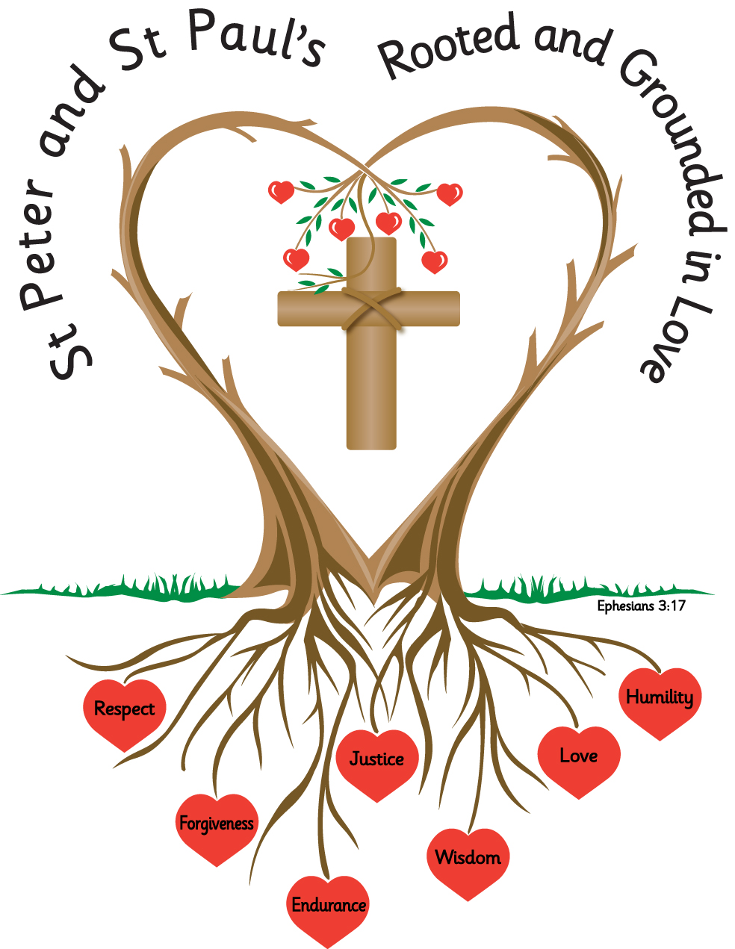
Name: _______________________ Year: 3

Homework
Spring 1 2027

Year 3 Homework - Spring Term 1
Please complete the task set each week and hand your homework booklet in on the last week of term.
Please note that children should continue to read daily to an adult, with reading records being signed and books and reading records returned to school.
All children have a TT Rockstars password and this should also be accessed weekly.

Week1
Add word endings -ing, -ed and -er to words of more than one syllable where the last syllable is stressed.
Practice handwriting and spellings; look, say, cover and write.
address addressed, addressing
upset upsetting
disturb disturbing disturbed
regret regretting regretted
answer answered answering
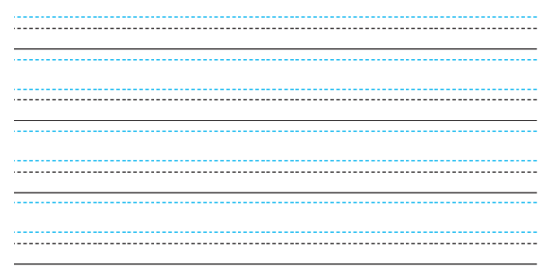


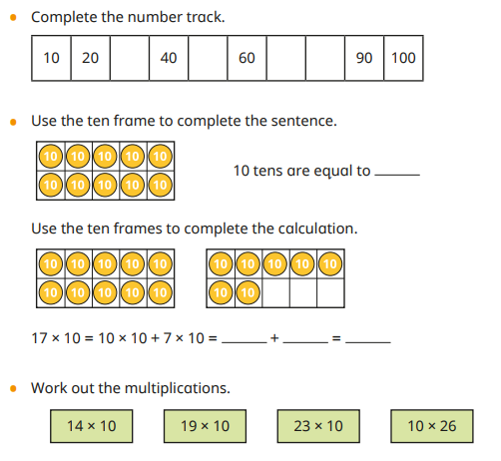
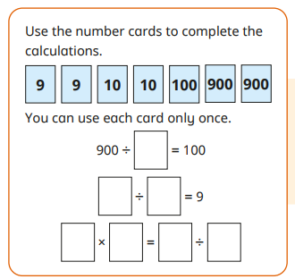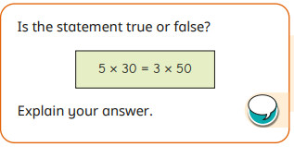

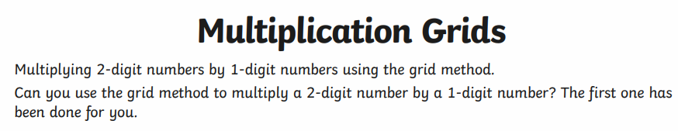
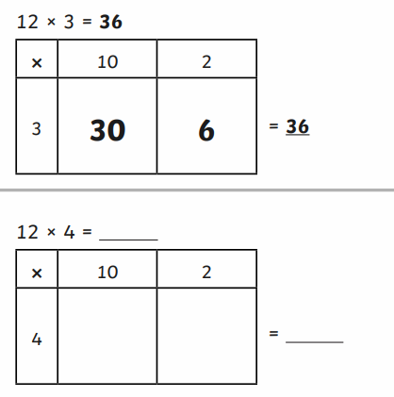
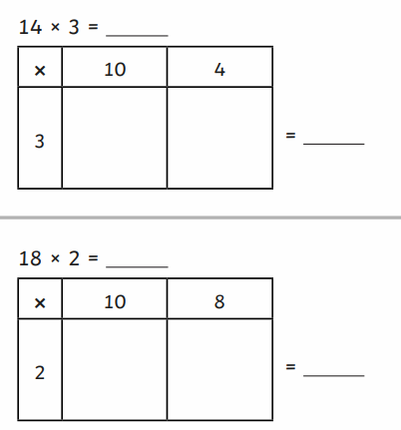

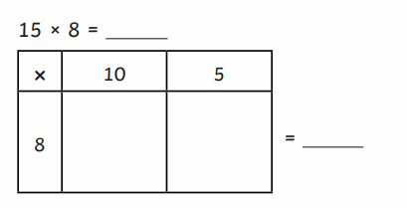

Week 2
Spell correctly and distinguish between the homophones,
Using the homophones below complete the sentences with the correct word.
- groan/grown
- berry/bury
- male/mail
The boy had __________________ 4cm in six months.
The postman delivered the _________________.
I watched the dog _____________________ his bone.
When the man bumped his head, he let out a loud ____________________.
There are eleven females and just one ________________ in the group.
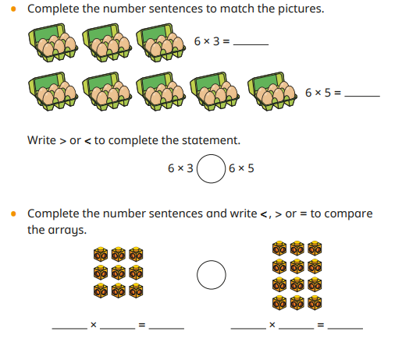
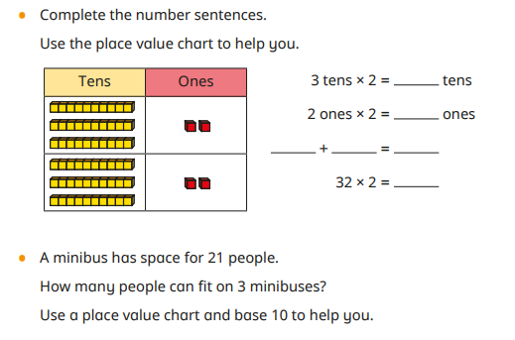

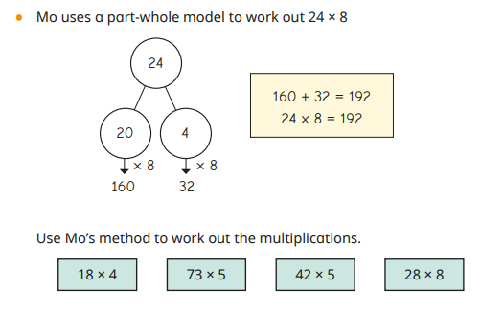

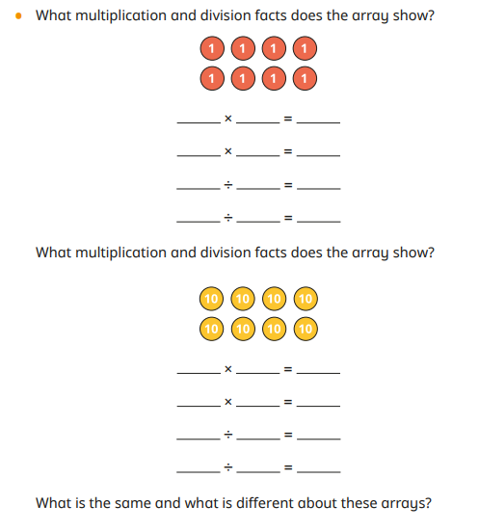

Week 3
Identify and spell irregular past tense verbs,
Mr Muddle has got his irregular past tense verbs all mixed up. He has also made some other mistakes. Please can you help him fix them. Rewrite the sentences correcting the mistakes.
They droav to the partee and mett her frends.
mrs Chester tuck the chyld by the hand and runned to the bus stop.
I spended the hole of Febuary in worm cloths.
He forgetted that he shud hav brort the potatos.

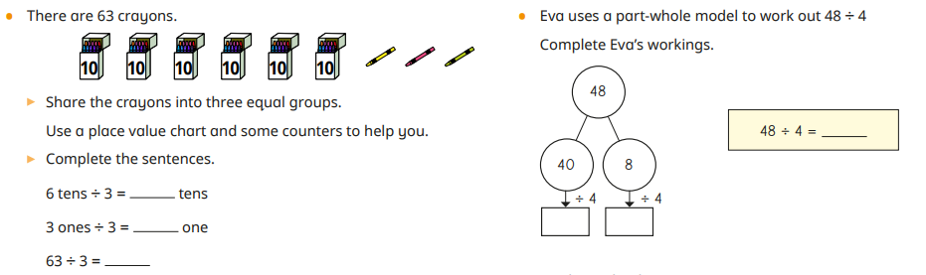

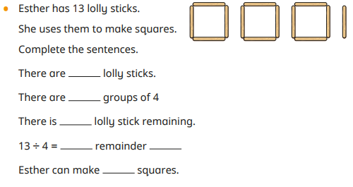
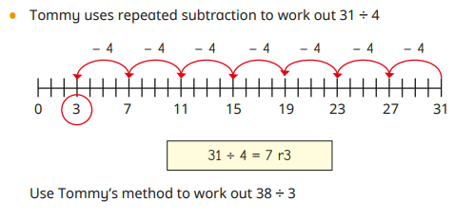

Week 4
Use the suffix -ly to words of more than one syllable, e.g. accidentally, magically.
Practice writing these words Choose 2 words and write 2 sentences including the word.
accident accidentally
occasion occasionally
practical practically
historic historically
critic critically
basic basically
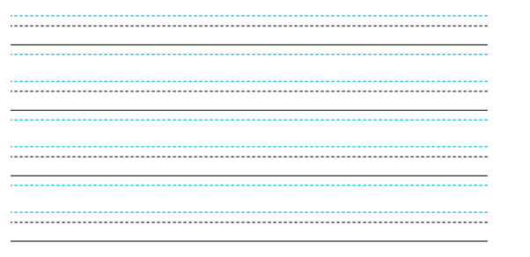

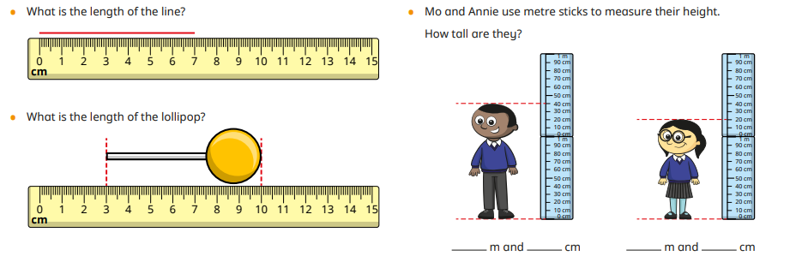
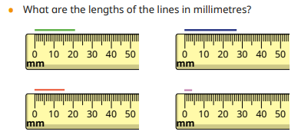
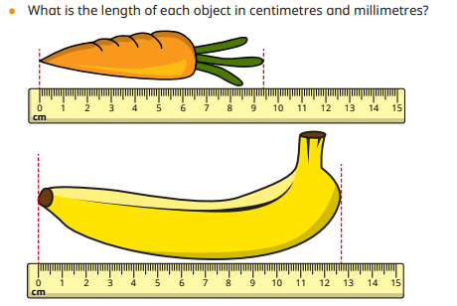
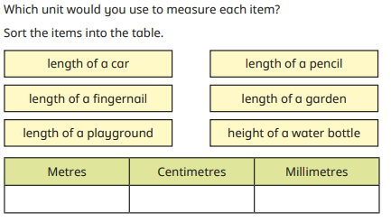

Week 5
Use the prefixes dis- and mis-, e.g. disagree, dismiss, misread, mistake.
Choose the right prefix for the word. dis or mis

____like
_____appear
____agree
_____behave
_____take
______read
Choose 2 words and include them in 2 separate sentences.
________________________________________________________________________________________________________________________________________________________________________________________________________________________________________________________________________________________________________________________________________________________________________________________________________________________

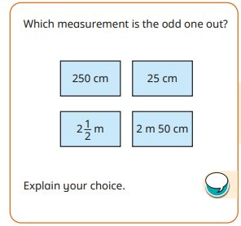
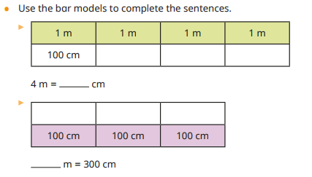

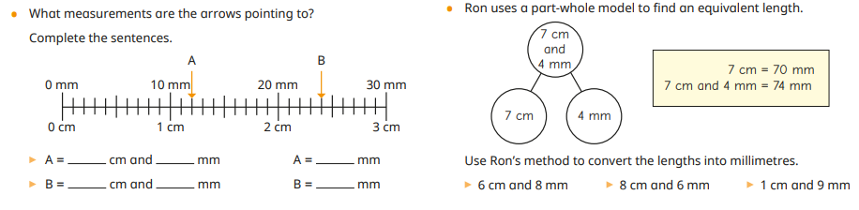

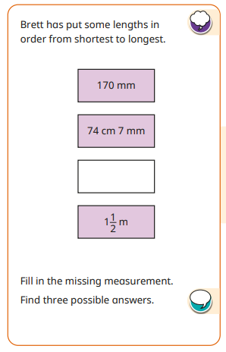
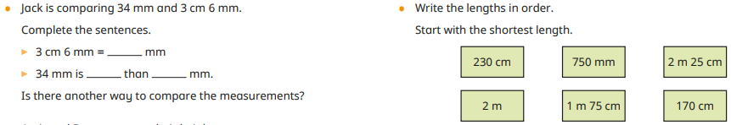

Week 6
Spell words with the /eɪ/sound spelt ei, eigh, or ey, e.g. vein, weigh, obey.
Match the word to the meaning
rein obey reign survey eight convey prey vein
If you do this, you follow the rules.
The name given to a blood vessel that returns blood to the heart.
This word means to communicate, to talk and offer ideas or information.
A rider might pull on this to stop a horse.
My sister is seven years old. She will be this age at her next birthday.
This word means the rule of a king or queen.
This can be the action of seizing and pouncing upon something, or it can be the name given to an animal that is killed or eaten by another animal.
Another word for this might be a questionnaire.
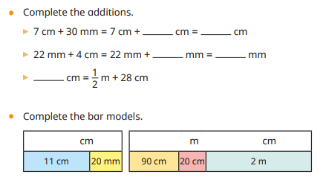
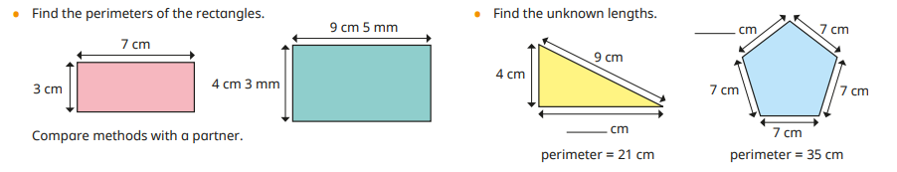
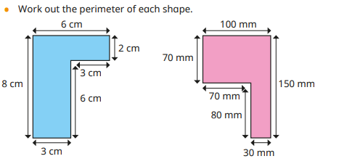

Task
Please complete the two reading comprehensions

- The Worst Witch – The First Flying Lesson

Based on The Worst Witch by Jill Murphy

Read the text carefully and answer the questions.

The First Flying Lesson (Adapted)

Mildred Hubble stood nervously beside her broomstick.

All around the playground, the other girls were climbing confidently onto their brooms and zooming into the air.

Miss Hardbroom swept past in her long black cloak.

“Keep your backs straight and your eyes forwards!” she called sharply.

Mildred swallowed hard.

She gripped her broomstick tightly and pushed off from the ground.

For one wonderful moment, she was flying.

The cold wind rushed past her face as she rose higher and higher above the castle towers.

Then suddenly, the broomstick wobbled.

“Oh no,” gasped Mildred.

Her broom lurched sideways, spinning wildly through the air.

Below her, the other pupils scattered in panic.

Miss Hardbroom stared upwards in horror as Mildred crashed untidily into a large black chimney pot.

Clouds of soot exploded everywhere.

For a moment, there was complete silence.

Then Ethel began to laugh.

Questions

Vocabulary (2a)

1. What does the word “lurched” suggest about the broomstick? (1 mark)

☐ Moved smoothly
☐ Moved suddenly and awkwardly
☐ Stayed still
☐ Floated gently

2. Find and copy one word that shows Mildred felt worried. (1 mark)

Retrieval (2b)

3. What were the other girls doing? (1 mark)

4. What did Mildred crash into? (1 mark)

5. Who laughed at the end? (1 mark)

Sequencing / Summarising (2c)

6. Put these events in order. (2 marks)

___ Mildred crashes into the chimney
___ Mildred pushes off from the ground
___ The broom begins wobbling
___ Ethel laughs

7. What is the main idea of this extract? (1 mark)

Inference (2d)

8. Why do you think Mildred “swallowed hard”? (2 marks)

9. What impression do we get of Miss Hardbroom?
Use evidence from the text. (3 marks)

Language (2g)

10. Why does the author describe soot “exploding everywhere”? (2 marks)

11. What effect does the short sentence “Then Ethel began to laugh” create? (2 marks)

Prediction (2e)

12. What do you think might happen next?
Use clues from the text to explain your ideas. (3 marks)

Greater Depth Question

13. How does the author build tension and humour throughout this extract?
Use evidence from across the text. (5 marks)

- The Worst Witch – The Potion Lesson

Based on The Worst Witch by Jill Murphy

Read the text carefully and answer the questions.

The Potion Lesson (Adapted)

The classroom smelled strongly of smoke and strange herbs.

Rows of bubbling cauldrons simmered gently while bottles filled with colourful liquids lined the shelves.

Mildred peered nervously into her cauldron.

“Add three drops of frog juice,” instructed Miss Cackle.

Carefully, Mildred tipped the bottle.

Plop!

Far too much frog juice splashed into the mixture.

At once, the potion began fizzing furiously. Thick purple foam spilled over the sides of the cauldron and spread across the desk.

Ethel smirked.

Miss Cackle hurried over. “Stand back!” she warned.

Suddenly, the cauldron let out a loud BANG!

Purple smoke shot towards the ceiling while bits of sticky potion splattered across the classroom walls.

For a moment, nobody moved.

Then the class burst into giggles.

Mildred’s face turned bright red.

Questions

Vocabulary (2a)

1. What does the word “furiously” suggest about the potion? (1 mark)

☐ Calmly
☐ Quietly
☐ Wildly and powerfully
☐ Slowly

2. Find and copy one word that shows Ethel enjoyed Mildred’s mistake. (1 mark)

Retrieval (2b)

3. What was lined along the shelves? (1 mark)

4. What ingredient did Mildred add too much of? (1 mark)

5. What colour was the foam? (1 mark)

Sequencing / Summarising (2c)

6. Put these events in order. (2 marks)

___ The potion spills over the cauldron
___ Mildred adds too much frog juice
___ The cauldron explodes
___ Miss Cackle warns the class

7. What is the main idea of this extract? (1 mark)

Inference (2d)

8. Why do you think Mildred’s face turned “bright red”? (2 marks)

9. What impression do we get of Mildred in this extract?
Use evidence from the text. (3 marks)

Language (2g)

10. Why does the author use the word “BANG!” in capital letters? (2 marks)

11. What effect does the description “purple smoke shot towards the ceiling” create? (2 marks)

Prediction (2e)

12. What do you think Miss Cackle might do next?
Use clues from the text to explain your answer. (3 marks)

Greater Depth Question

13. How does the author make Mildred’s mistake both dramatic and funny?
Use evidence from across the text. (5 marks)

