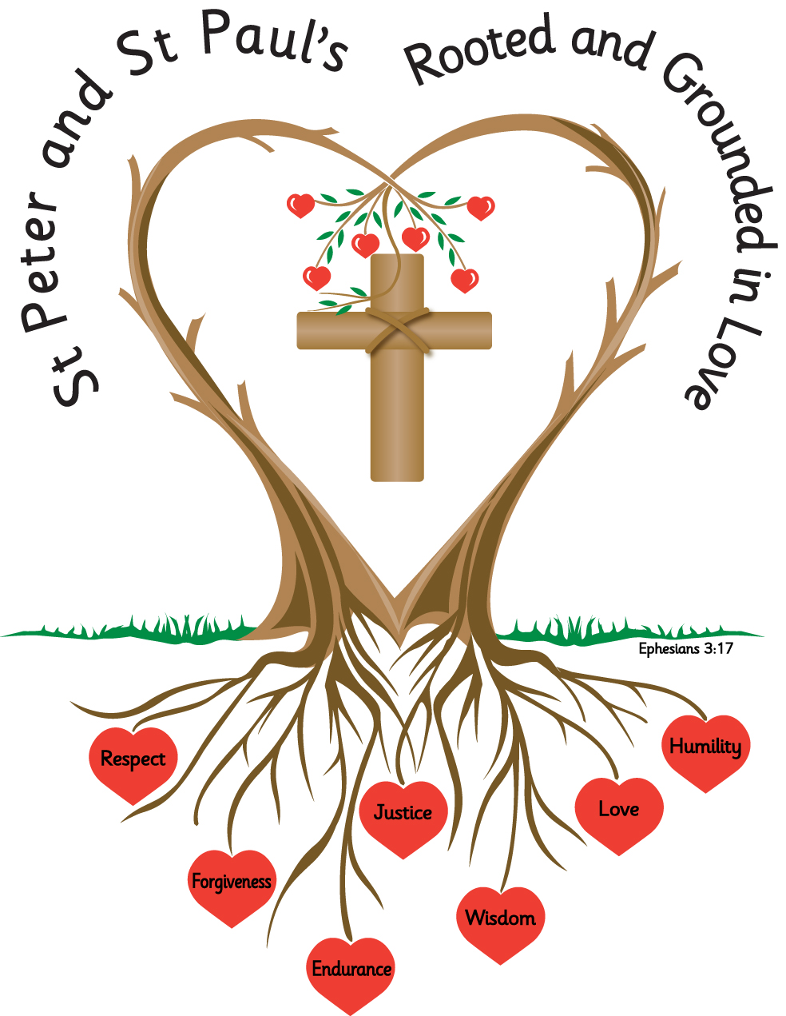
Name: _______________________ Year: 3

Homework
Autumn 2 2026

Year 3 Homework - Autumn Term 2
Please complete the task set each week and hand your homework booklet in on the last week of term.
Please note that children should continue to read daily to an adult, with reading records being signed and books and reading records returned to school.
All children have a TT Rockstars password and this should also be accessed at weekly.
Week 1
Use a dictionary to find the following words, write the word 5 times in your best cursive handwriting and write down the meaning;
centre
accident
breath
library
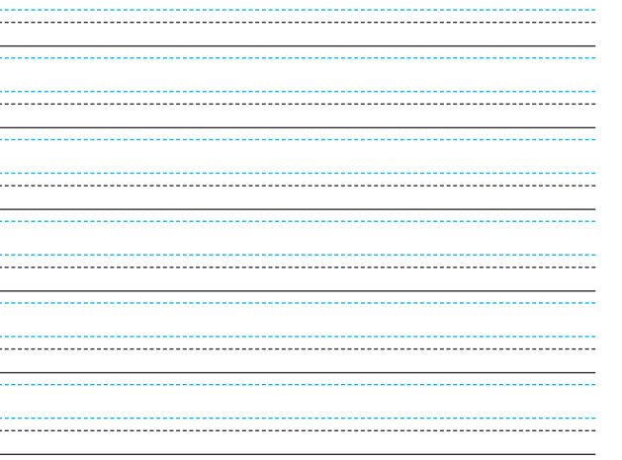

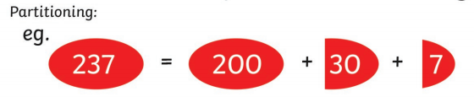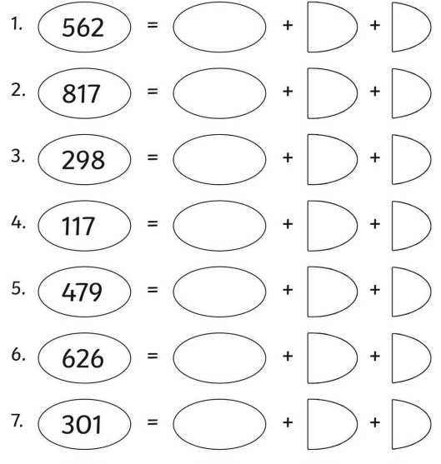

Week 2
This week we are continuing our work on homophones.
Using your knowledge of homophones, write a sentence for each homophone, make sure your sentence uses the right homophone.
- meet meat
- plain plane
- here hear
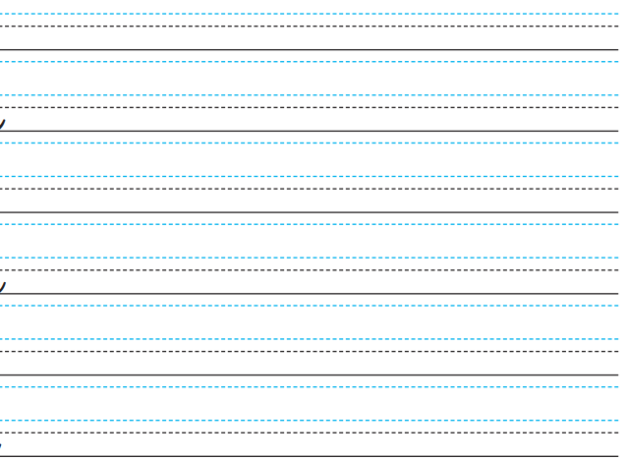

Practise your 2x tables.

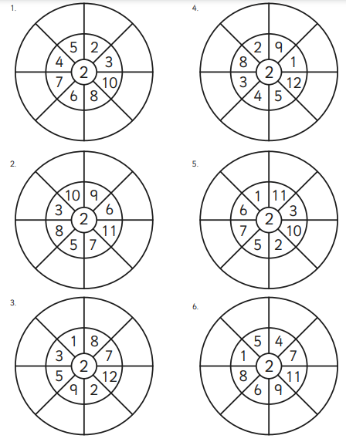

Week 3
This week we are looking at;
adding -es to nouns ending in y, e.g. strawberry, strawberries
adding -es to nouns and verbs ending in y, e.g. baby, babies; copy, copies.
Identifying and spelling irregular plurals, e.g. potato, potatoes.

Circle the irregular plurals
stories copies echoes memories heroes fries strawberries libraries potatoes

Add in the missing letters;
stor _ _ s
mem_ r_ e_
co _ _ _ s
fr_ _ _
pot _ t _ _ s
str _ _ be _ _ _es
lib _ _ _ ies
ech _ e _
Choose 3 plurals, from the list, and write 3 sentences including your plural.
____________________________________________________________________________________________________________________________________________________________________________________________________________________________________________________________________________________________________________________________________________________________________________________________________________________________________________________________________________________________________________________________________________________________________________________________________________________________________________________________________________________________________________________________________________________________________________________________________________________________________________________________________

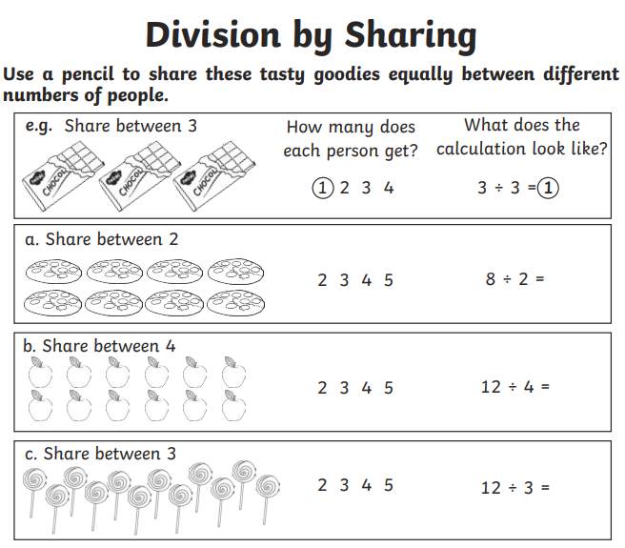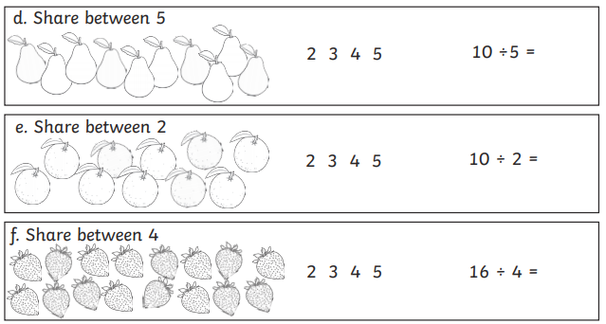

Week 4
Add the suffix -ous, e.g. poisonous, enormous, adventurous.

Remember when the word ends in e, the e is dropped before the -ous is added.
Note: when adding -ous to the word space, the e is dropped and ious is added.

Add -ous to these words
adventure
fame
nerve
ridicule
continue
space

Choose 2 words and write a sentence for each word.
_____________________________________________________________________________________________________________________________________________________________________________________________________________________________________________________________________________________________________________________________________________________________________________________________________________________

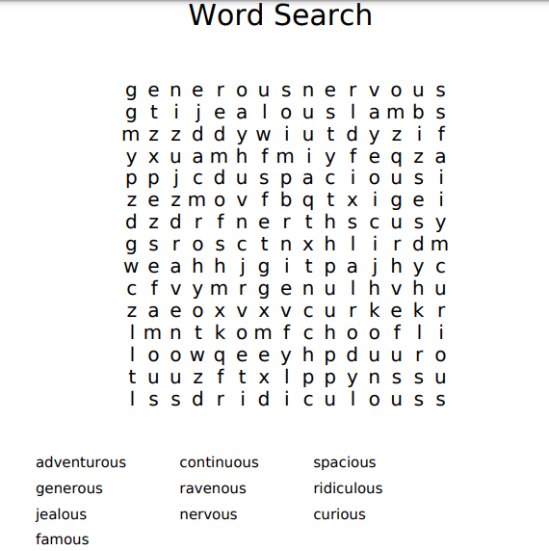

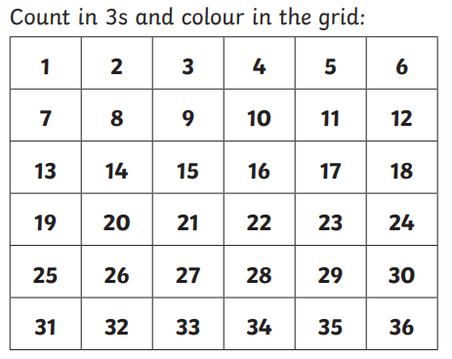

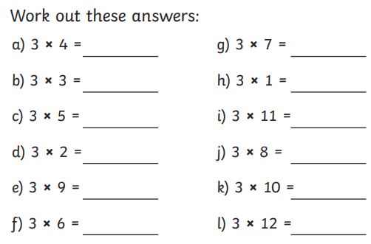

Week 5
Spell words with endings sounding like /tʃə/ spelt -ture, e.g. picture, nature.
Use these words to fill the gaps
adventure | picture | furniture | creature
pasture | temperature | nature | fixture

The group of women went on an ____________________ in __________________.
The new ________________ in the zoo proved most popular.
We have a football ____________ every Saturday morning at the park.
My parents bought some old ___________________ from the 19th century.
The sheep loved to run around in the enormous ___________________.
Mrs Young paid a lot of money for the famous _____________________.
The nurse took the child's ____________________ again and again.
_______________________________________________________________________________________________
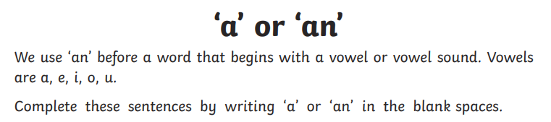

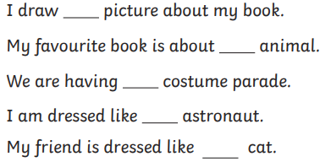
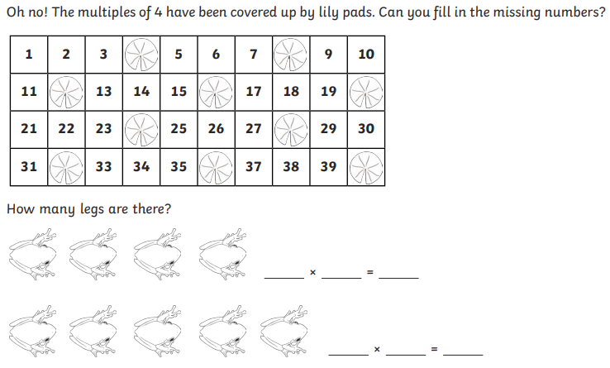

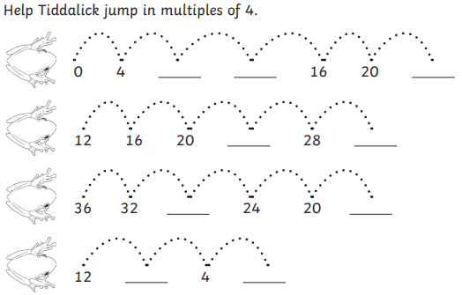

Week 6
Use the possessive apostrophe (singular)
Rewrite the sentences below adding in the apostrophes.
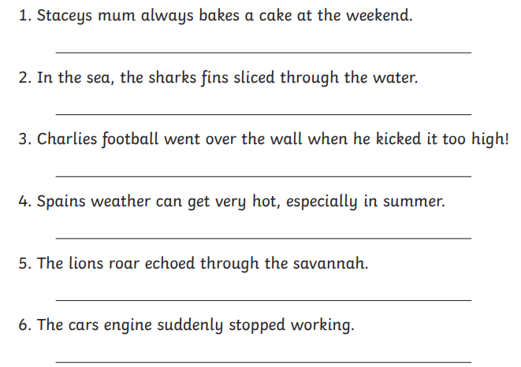
_________________________________________________________________________________
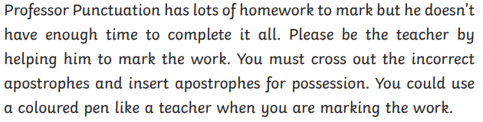
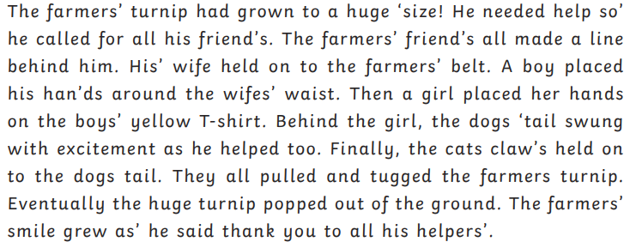
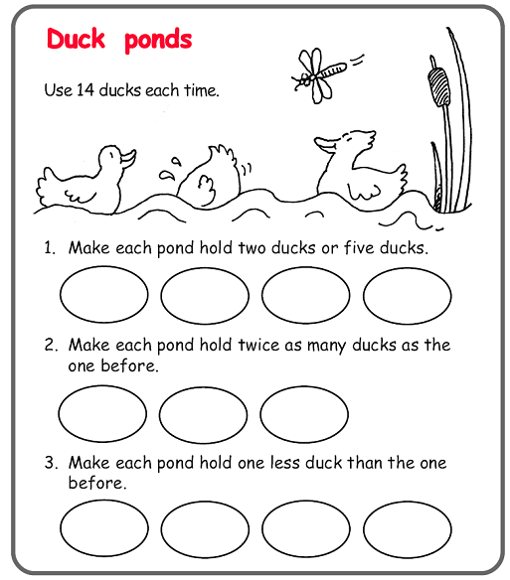

Task
Please complete the two reading comprehensions below.

- The Magic Faraway Tree – The Land of Do-As-You-Please

Based on The Magic Faraway Tree by Enid Blyton
(Adapted for assessment purposes)

Read the text carefully and answer the questions.

The Land of Do-As-You-Please (Adapted)

The children climbed through the trapdoor and stared around in amazement.

This new land was noisier than any they had visited before. Children zoomed past on roller skates while others bounced high on trampolines set amongst the trees.

Nobody seemed to be following any rules.

One boy rode a bicycle straight through the middle of a flower bed, laughing wildly as petals flew into the air behind him.

Nearby, a girl ate three enormous ice creams at once.

“This place is extraordinary,” whispered Beth.

Moon-Face nodded. “This is the Land of Do-As-You-Please,” he explained. “Everyone can do exactly what they want.”

At first, the children thought it seemed wonderful.

Joe climbed onto a wooden cart and rolled downhill as fast as he could. Silky danced across the grass singing loudly at the top of her voice.

But after a while, the land began to feel strange.

Nobody helped each other. People pushed past one another without saying sorry. Everywhere the children looked, there was mess, noise and confusion.

A little dog barked nervously as children raced wildly around it.

Beth frowned. “I don’t think I like this land anymore,” she admitted quietly.

Questions

Vocabulary (2a)

1. What does the word “extraordinary” mean in this text? (1 mark)

☐ Ordinary
☐ Strange and unusual
☐ Quiet
☐ Frightening

2. Find and copy one word that shows the land was untidy. (1 mark)

Retrieval (2b)

3. What were some children using to bounce high in the air? (1 mark)

4. What did the boy ride through? (1 mark)

5. Who said, “I don’t think I like this land anymore”? (1 mark)

Sequencing / Summarising (2c)

6. Put these events in order. (2 marks)

___ Beth changes her mind about the land
___ The children arrive in the land
___ Joe rides downhill on a cart
___ The children notice the mess and confusion

7. What is the main idea of this extract? (1 mark)

Inference (2d)

8. Why do you think the children liked the land at first? (2 marks)

9. Why does Beth change her opinion later in the extract?
Use evidence from the text. (3 marks)

Language (2g)

10. Why does the author describe petals “flying into the air”? (2 marks)

11. What effect does the phrase “mess, noise and confusion” create? (2 marks)

Prediction (2e)

12. What do you think the children will do next?
Use clues from the text to explain your answer. (3 marks)

Extention Question

13. How does the author show that the Land of Do-As-You-Please is exciting but also problematic?
Use evidence from across the text. (5 marks)

- The Magic Faraway Tree – The Land of Secrets

Based on The Magic Faraway Tree by Enid Blyton
(Adapted for assessment purposes)

Read the text carefully and answer the questions.

The Land of Secrets (Adapted)

The new land above the Faraway Tree was strangely quiet.

As the children climbed through the trapdoor, they noticed that everyone spoke in whispers. People leaned closely together, covering their mouths as they talked.

Joe lowered his voice immediately.

“It feels odd here,” he murmured.

Tall silver trees surrounded winding paths that disappeared into the mist. Hidden doors were built into the tree trunks, and every now and then, someone would slip silently through one before quickly shutting it behind them.

Silky glanced around nervously.

“I wonder what everybody is hiding,” she whispered.

Suddenly, the children heard soft footsteps behind them.

They spun around.

An old woman stood there holding a tiny golden key.

“You must not ask questions in the Land of Secrets,” she warned quietly.

Before the children could reply, she disappeared into the mist.

For a few moments, nobody spoke.

Even Moon-Face looked uneasy.

Questions

Vocabulary (2a)

1. What does the word “murmured” mean? (1 mark)

☐ Shouted loudly
☐ Spoke softly
☐ Laughed happily
☐ Cried sadly

2. Find and copy one word that shows Moon-Face felt uncomfortable. (1 mark)

Retrieval (2b)

3. What surrounded the winding paths? (1 mark)

4. What was the old woman holding? (1 mark)

5. What were people doing when the children first arrived? (1 mark)

Sequencing / Summarising (2c)

6. Put these events in order. (2 marks)

___ The old woman gives a warning
___ The children enter the land
___ The children hear footsteps
___ Silky wonders what people are hiding

7. What is the main idea of this extract? (1 mark)

Inference (2d)

8. Why do you think the children lowered their voices? (2 marks)

9. What impression do we get of the Land of Secrets?
Use evidence from the text. (3 marks)

Language (2g)

10. Why does the author describe the paths disappearing “into the mist”? (2 marks)

11. What effect does the warning “You must not ask questions” create? (2 marks)

Prediction (2e)

12. What do you think the children might discover in this land?
Use clues from the text to explain your answer. (3 marks)

Extention Question

13. How does the author create a mysterious atmosphere throughout this extract?
Use evidence from across the text. (5 marks)

