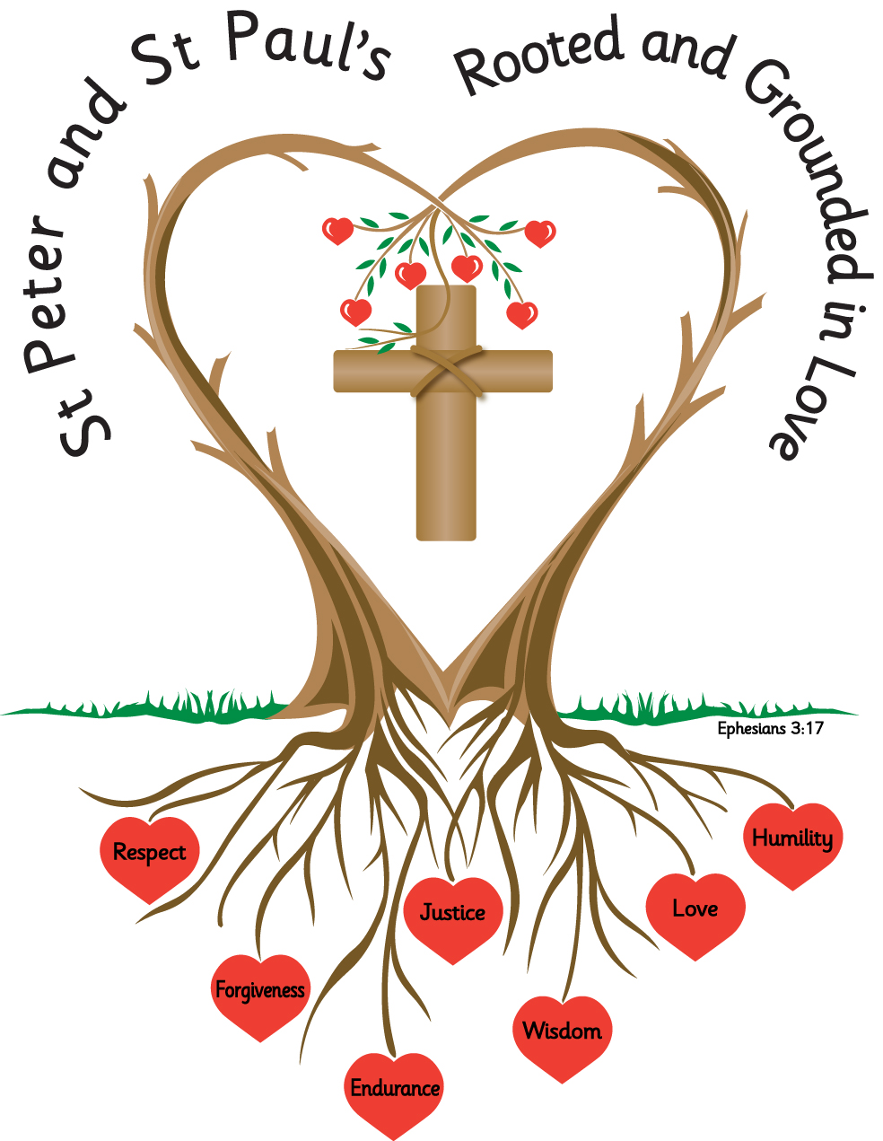
Name: _______________________ Year: 3

Homework
Autumn 1 2026

Year 3 Homework - Autumn Term 1
Please complete the task set each week and hand your homework booklet in on the last week of term.
Please note that children should continue to read daily to an adult, with reading records being signed and books and reading records returned to school.
All children have a TT Rockstars password and this should also be accessed weekly.
The year 3 spelling list are in the Spelling Ideas document.

Week 1
Spelling
describe describing described notice noticing noticed promise promising promised strange stranger strangest

Practise this weeks spelling rule by adding the relevant endings to the root word, the first one has been done for you.
Root | -ing | -ed | -er | -est
describe | describing | described
notice
promise
strange

Choose 3 words, from this week’s spelling list and write a sentence including the spelling word.
______________________________________________________________________________________________________________________________________________________________________________________________________________________________________________________________________________________________________________________________________________________________________________________________________________________________________________________________________________________________________

This week we have been remembering to use capital letters and full stops in our writing. Compete the activity below.

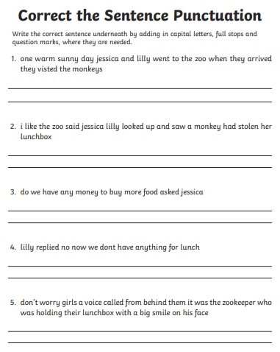

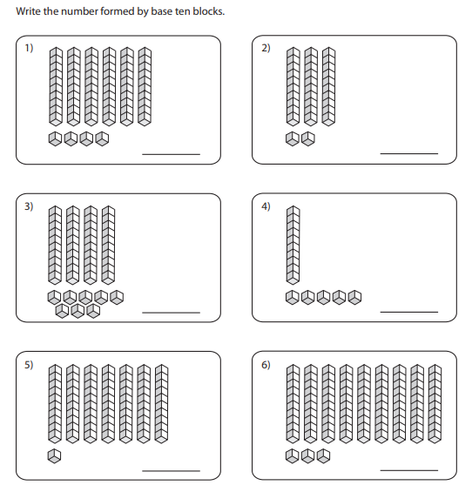
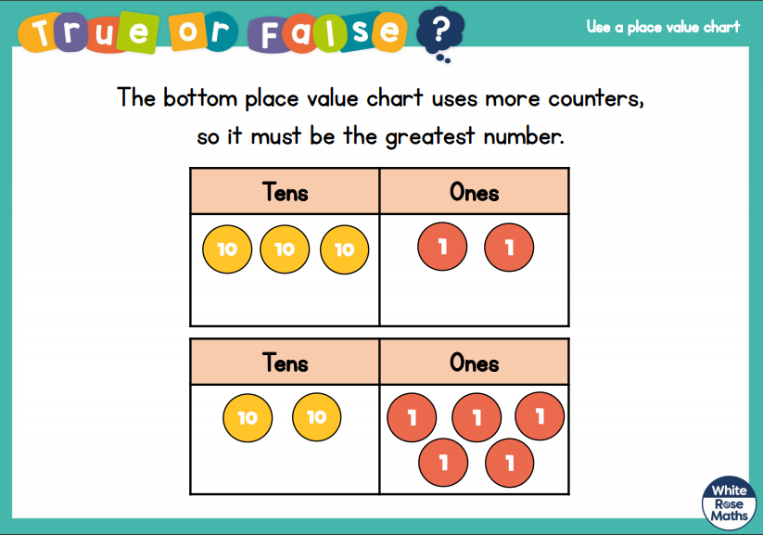
EXT

Week 2
This week we have looked at the following homophones. Match the correct homophone to the meaning.

great to smash or divide into pieces
grate relating or belonging to us or ourselves

brake to come out in a steady stream

poor device used to stop or slow down a vehicle

our large or amazing

break to have little or no money

pour to rub or make into small parts

hour period of time

Choose a pair of homophone and write a sentence for each word.

Write the number represented in the place value grid. The first one

has been done for you

.
Hundreds | Tens | Ones
372
Hundreds | Tens | Ones
Hundreds | Tens | Ones
Hundreds | Tens | Ones
Hundreds | Tens | Ones
Hundreds | Tens | Ones

EXT:
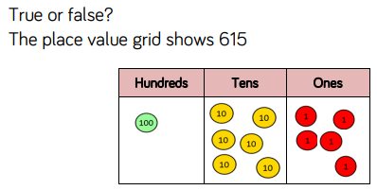

Week 3
This week we have been looking at irregular past tense verbs;
break broke
hear heard
think thought
find found
see saw
Choose the correct past tense verb to replace the underlined verb in each sentence.

I break my arm last week.
I hear the new song on the radio.
I think about the party I attended.
I find a new way home.
I see a red car drive down the road.

Order these numbers from smallest to largest. Write the numbers in the correct order underneath.
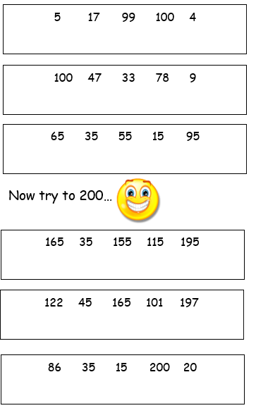
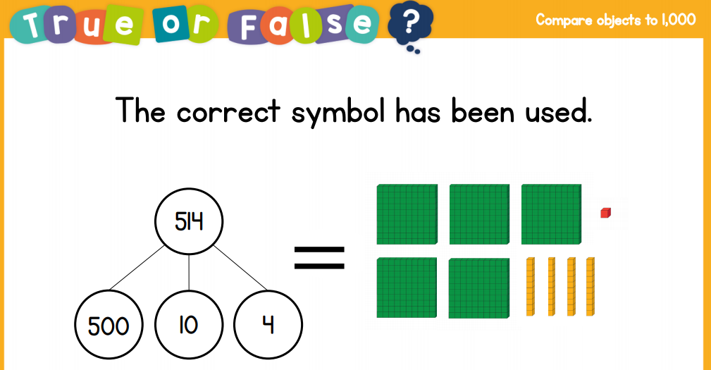
EXT:

Week 4
Add the suffix -ly
sadly strangely actually simply angrily happily

Select 3 words with the suffix -ly and write one sentence for each
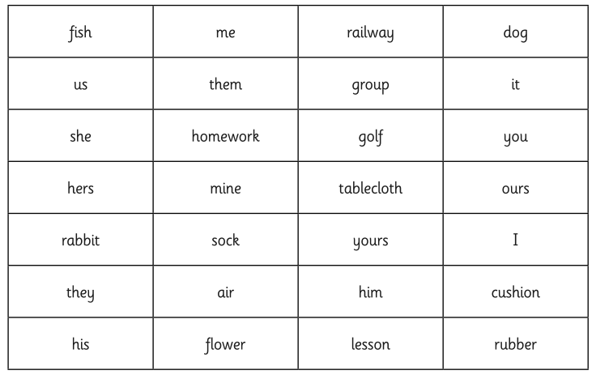
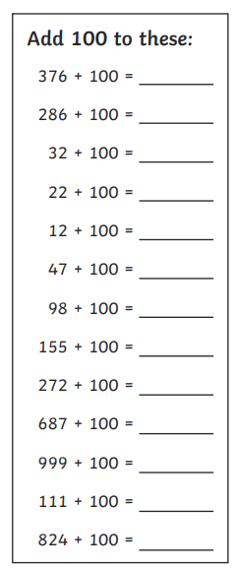
Week 5
Add the endings -ing, -ed and -er to words of more than one syllable where the last syllable is not stressed.
Write out your spellings

opening
opener
opened
gardening
gardener
gardened
following
follower
followed
listening
listener
listened

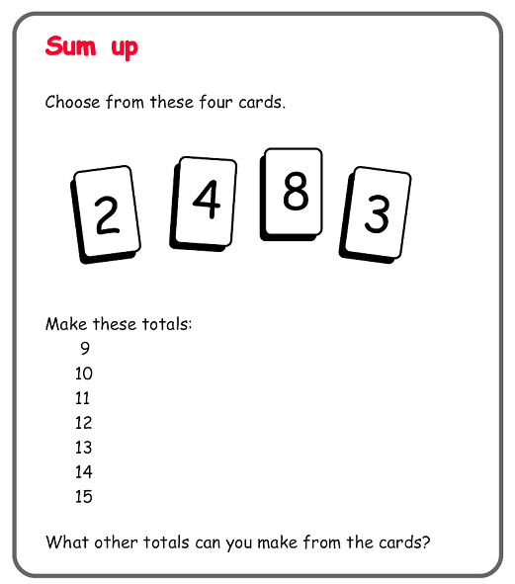

Week 6
Read through your spellings, cover them up and then write them down.
Spelling List | Write | Cover and rewrite
reread
rewrite
remind
revisit
refresh
remove
review
remember
reuse
recycle

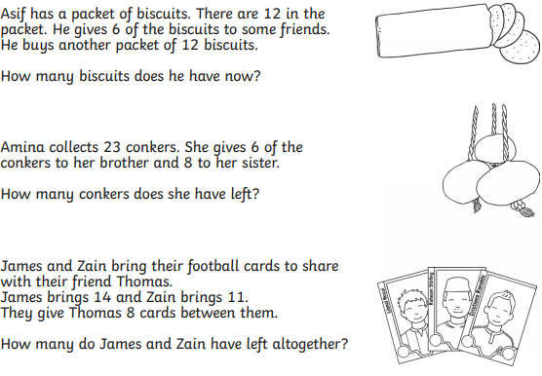
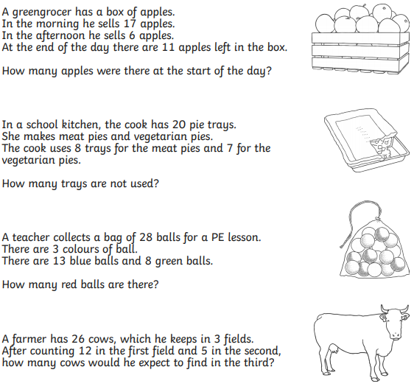

Task
Please complete the two reading comprehensions.

The Magic Faraway Tree

Based on The Magic Faraway Tree by Enid Blyton
(Adapted)

Read the text carefully and answer the questions.

- The Land of Treats (Adapted)

The children climbed higher and higher up the Faraway Tree until they reached the ladder at the very top.

A strange new land had arrived that morning.

As Joe pushed open the little wooden trapdoor, a delicious smell floated down towards them. It smelled of warm cakes, melted chocolate and sweet strawberries.

“This must be the Land of Treats!” said Beth excitedly.

The children scrambled up quickly.

All around them were enormous tables piled high with food. Cakes covered in thick icing stood beside bowls of shining sweets. Rivers of lemonade sparkled in the sunlight.

Moon-Face laughed happily. “Be careful you don’t eat too much,” he warned.

But already, Silky was nibbling a tiny pink bun.

Joe reached for a slice of chocolate cake while Beth filled her pockets with sugared almonds.

Everywhere they looked, people were eating and laughing. Music drifted through the warm air, and colourful flags fluttered overhead.

For a while, the children forgot completely about time.

Then suddenly, the ground gave a little shiver.

“The land is getting ready to move!” cried Moon-Face.

At once, the children dropped their cakes and raced back towards the trapdoor.

Questions

Vocabulary (2a)

1. What does the word “scrambled” suggest about how the children climbed? (1 mark)

☐ Slowly and carefully
☐ Quickly and excitedly
☐ Quietly and nervously
☐ Sadly and tiredly

2. Find and copy one word that shows the lemonade looked bright. (1 mark)

Retrieval (2b)

3. What had arrived at the top of the tree? (1 mark)

4. Name two foods mentioned in the text. (2 marks)
1.
2.

5. Who warned the children not to eat too much? (1 mark)

Sequencing / Summarising (2c)

6. Put these events in order. (2 marks)

___ The ground begins to shake
___ The children climb the tree
___ The children rush back to the trapdoor
___ The children see huge tables of food

7. What is the main idea of this extract? (1 mark)

Inference (2d)

8. Why do you think the children “forgot completely about time”? (2 marks)

9. How do we know the Land of Treats is exciting and magical?
Use evidence from the text. (3 marks)

Language (2g)

10. Why does the author describe “rivers of lemonade”? (2 marks)

11. What effect does the phrase “music drifted through the warm air” create? (2 marks)

Prediction (2e)

12. What do you think might happen if the children do not escape the land in time?
Use clues from the text to explain your ideas. (3 marks)

Extension Question

13. How does the author make the Land of Treats seem appealing to the reader?
Use evidence from across the text. (5 marks)

- The Magic Faraway Tree – The Land of Tempers

Based on The Magic Faraway Tree by Enid Blyton
(Adapted for assessment purposes)

Read the text carefully and answer the questions.

The Land of Tempers (Adapted)

When the children climbed into the new land above the Faraway Tree, everything seemed normal at first.

The sun was shining brightly, and a gentle breeze rustled through the trees.

But after only a few minutes, Beth began to feel strangely cross.

Joe stamped his foot angrily because his shoelace had come undone.

Moon-Face frowned. “Oh dear,” he muttered. “I think this is the Land of Tempers.”

As they walked further, they noticed people arguing everywhere.

Two women were shouting beside a market stall. Nearby, a man slammed a door so hard that the windows rattled.

Even the birds sounded angry. Their sharp cries echoed across the sky.

Suddenly, Silky snapped impatiently at Joe.

“Well, stop walking so slowly!” she said.

Joe glared back at her.

For a moment, nobody spoke.

Then Moon-Face sighed deeply. “This land changes everyone,” he explained sadly. “If we stay too long, we may begin arguing too.”

The children looked at one another nervously and hurried back towards the tree.

Questions

Vocabulary (2a)

1. What does the word “snapped” mean in this sentence? (1 mark)

☐ Spoke kindly
☐ Spoke angrily
☐ Spoke quietly
☐ Spoke sadly

2. Find and copy one word that shows Joe was angry. (1 mark)

Retrieval (2b)

3. What was the weather like at the beginning? (1 mark)

4. What did the man do to the door? (1 mark)

5. Why did Moon-Face think it was the Land of Tempers? (1 mark)

Sequencing / Summarising (2c)

6. Put these events in order. (2 marks)

___ Silky speaks impatiently
___ The children enter the land
___ The children hurry back to the tree
___ People are seen arguing

7. What is the main idea of this extract? (1 mark)

Inference (2d)

8. Why do you think the children became nervous at the end? (2 marks)

9. What impression do we get of the Land of Tempers?
Use evidence from the text. (3 marks)

Language (2g)

10. Why does the author include details like “windows rattled” and “sharp cries echoed”? (2 marks)

11. What effect does the phrase “glared back” create? (2 marks)

Prediction (2e)

12. What do you think would happen if the children stayed longer in the Land of Tempers?
Use clues from the text to explain your answer. (3 marks)

Extension Question

13. How does the author build an uneasy atmosphere throughout this extract?
Use evidence from across the text. (5 marks)

