

Welcome to Year 3 September 2026

A big welcome back from Mrs Bradshaw your class teacher and a warm welcome from Mrs Hussain our class teaching assistant; we are so excited to be teaching your child this year. Mr. Ferguson will take the children for PE. I hope that this booklet provides you with some useful information about school life. If at any time you have any queries or concerns and would like to speak to me, I am always happy to try and help you as soon as possible.
l.bradshaw@st-peter-st-pauls.lancs.sch.uk
As I am teaching the class, emails will usually be responded to at the end of the school day and only during working hours. If your concern/query cannot be answered by email and needs to be discussed in depth I can arrange to call you at a convenient time. If you need to speak to me urgently, please ring the office 01254 884522 and staff will pass a message on for me to ring you when I am out of class. I hope that you always feel that you can approach me with any problems or concerns, however if you are ever not satisfied with something in school and you feel that you cannot speak to me directly you can speak to Mrs Chandler who is our Key Stage Two Leader, in the same ways as outlined above. Mrs Chandler’s email is:
a.chandler@st-peter-st-pauls.lancs.sch.uk

Our topics this year will be:
Autumn 1 | Autumn 2 | Spring  1 | Spring  2 | Summer 1 | Summer 2
Living in a Rock – The Stone Age | Discovering Germany – The Black Forest | Journey into Rome – The Romans | Riveting Rivers | Location, Location, Location – Remarkable Rishton

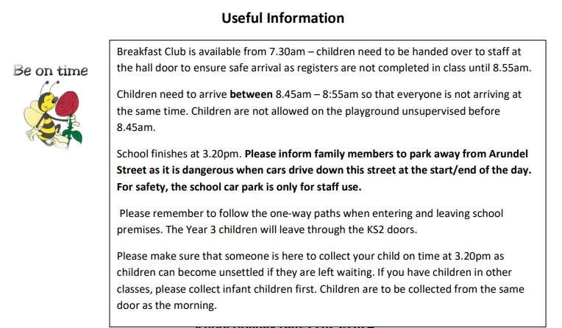

School Holiday Dates 2026-2027

 | Term Begins | Half Term Holidays | Term Ends
Autum | 1st September 2026 | 19th October –  30th October 2026 | 18th December 2026
Spring | 4th January 2027 | 15th February –  19th February 2027 | 25th March 2027
Summer | 15th April 2027 | 31st May – 4th June 2027 | 21st July 2027

Please do not book holidays in term time as absences cannot be authorised and it means children will have 2 unauthorised absences per day as registration takes place in the morning and afternoon. As we are unable to authorise days off during term time, we ask that parents please only book holidays when we are off school. The Department for Education has an expectation of 96% attendance throughout the year, which is monitored by our Attendance Lead. Whilst we appreciate that some absences may be due to unavoidable illness, we are statutorily obliged to notify parents if attendance drops below this level.

Uniform - Please remember to label all items of clothing clearly to make it easier to return any lost items. We need to be able to read the names easily if we are to get them back to you.
School Bags - Please do not bring any bags other than the red school reading book bag which can be easily stored in class.
Waterproof Pants and Wellingtons - We encourage all children to have a pair of waterproof pants and wellingtons (with a small bag to put them in) to keep in school. The children will often take part in outdoor learning activities and wet playtimes.
Earrings – It is better if children do not wear earrings for school but if they choose to please make sure they are plain small studs. These need to be removed (at home) on Tuesdays and Wednesdays for PE as they cannot be covered over. Please also note that earrings should not be worn for swimming, children will not be permitted into the pool, if they are wearing earrings.
Water Bottles - Please send in a water bottle with a sports top rather than a lid that unscrews. As we are a Healthy School, children are only allowed to drink plain water during lesson time (juice or flavoured water are only allowed in lunch boxes). Water bottles will be sent home each day so that they can be washed out and refilled.
Dinner Money – The cost of school dinners is £2.50 per day which should be paid online. If children bring packed lunches, they do have the option of having a school lunch on Fridays for Family Favourites and this can be booked online.
Snack – Children are allowed to bring a piece of fruit for morning snack. These are no longer provided in Key Stage 2 and need to brought from home.
Reading Books – Please ensure these are in bags on the days we change which are Mondays and Fridays. It is very important that children practice their reading skills at home by reading to an adult on a regular basis. This should include asking children about what they have read to develop their comprehension skills. Ideally, this needs to be for a few minutes each day. Please sign reading records to show that your child has read and when the book has been finished and is ready for changing.
Homework – Homework booklets are given out at the start at each half term and are also available on the website under our class section. It includes a weekly spelling challenge which will identify a particular spelling pattern/skill to learn each week. This will be introduced to the children in class on a Monday. It also includes a short Maths activity that fits in with what we have been doing in class that week.
Mobile phones - Children are not allowed phones in school unless parents have filled in a form requesting that they need one because they walk home on their own.
Our PE days are Tuesdays and Wednesdays – Pupils will need a full PE kit in school at all times. Children will bring home kits at the end of each month to be washed. It is important that these are returned to school or children will be unable to take part in the lesson.

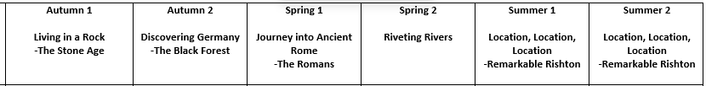
Our topics for this year will be

More detailed information can be found on the class page on the school website.

Class Trip
We will be planning to take the children out of school later in the year and will provide information on this. We will set up payment on the online system in advance in case you want to pay instalments.

Swimming Lessons
We will be taking the Year 3 children swimming, and this will hopefully be in January 2025. Swimming usually takes place on a Thursday morning. We ask that all children are in school by 8:45am, ready to leave promptly at 8:55 am.
Website
Please see our class section of the website for photos and more information on our learning. We also have a Facebook page which provides lots of information about life at school.
Superstar Celebration This will take place every Friday morning (from 6th Sept) and parents are welcome to attend. A Superstar certificate is awarded to one child from each class and children can bring in certificates and awards from meaningful activities completed out of school hours. Each month a ‘megastar’ certificate is awarded in each class to someone who consistently goes above and beyond.
Breakfast Club and After School Club
A new registration form will be sent out to all users of the clubs, and we ask that you please read the terms and conditions carefully. The after-school club needs to close promptly at 5.45pm and children must be collected by this time to avoid having to pay a late collection charge. All bookings need to be made in advance using the online payment system and unfortunately, due to numbers having increased significantly, there is a chance your child may not have a place if they are not booked in as we have to ensure we have the appropriate staffing in place.

Behaviour and Positive Recognition
In school, we encourage everybody to behave in ‘The St Peter and St Paul’s Way’, with our school code of conduct being firmly based on our core Christian values.

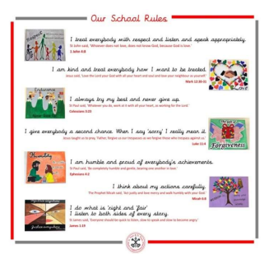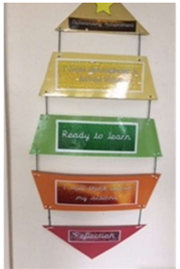
Wherever possible, children are praised for behaving well and where possible this is often by positive verbal recognition. A project we were involved with involving other schools/surveys with our parents highlighted that there is very little value to a child when they are rewarded for doing things which are the ‘norm’ or ‘generally expected’ and that instant verbal praise is the most effective reward for children as it has far more meaning to them at the time. We have a behaviour ladder (as above) and children’s names all start on green ‘ready to learn’ at the start of each day. Children may be asked to move their name up/down the ladder. If children repeatedly behave in a negative manner after several reminders and have moved their name, they may be asked to spend time in 'Reflection' during their break time. If this happens on several occasions, parents will be notified and children may end up missing out on some of the additional fun aspects of school.

We also use a system linked to learning powers where we choose a specific ‘success criteria’ to work on each week. These are based on: making connections and having curiosity, changing and learning, building resilience, having strategic awareness, creativity and learning relationships. The intention is that each child will add their name to the wall of recognition by the end of the week for achieving one of the learning powers and that collectively as a class they can all achieve this. We have seen the pleasure the class get from this accomplishment and that they all try to encourage each other and recognise when individuals have demonstrated the learning power.

There are 8 learning powers:
• Don’t give up Donald Duck
• Concentrate Colin Caterpillar
• Co-operate Tim & Tina Tortoise
• Have a go Harold Hedgehog
• Curious Cathy Camel
• Keep improving Ivy Insect
• Imagination Isabel Iguana
• Enjoy Learning Edward Elephant

There is a video on the school website where children are explaining the Learning Powers
https://www.st-peter-st-pauls.lancs.sch.uk/school-council/

We look forward to working with you and your family this year!
Mrs Bradshaw, Mrs Astbury and Mrs Crossley.

