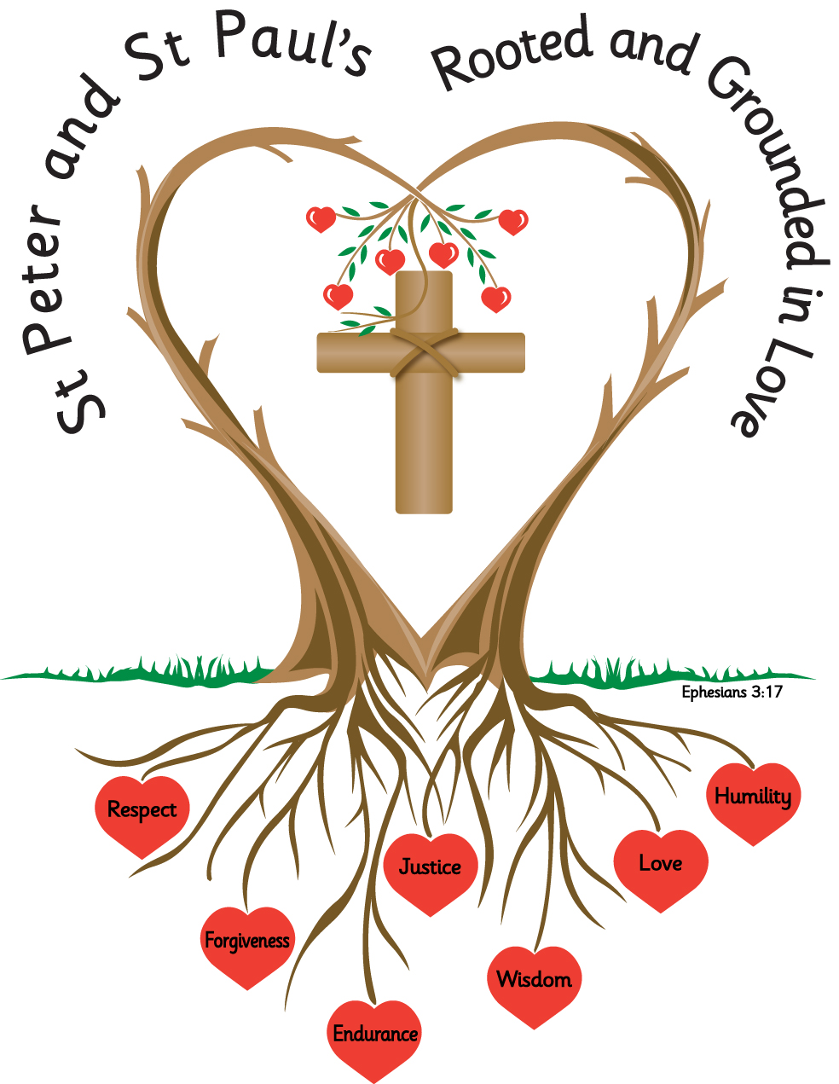

Welcome to Year 4
September 2026

A huge welcome back from Miss Flavell, your class teacher, and Mrs Whittle and Mrs Montgomery, our class teaching assistants; we are so excited to be teaching your child this year.
I hope that this provides you with some useful information about school life and if at any time you have any queries or concerns and would like to speak to me, I am always happy to try and help you as soon as possible. My email address is:
e.flavell@st-peter-st-pauls.lancs.sch.uk
As I am teaching the class during the day, emails will usually be responded to at the end of the school day and only during working hours. If your concern/query cannot be answered by email and needs to be discussed in depth, I can arrange to call you at a convenient time.
If you need to speak to me urgently, please ring the office 01254 884522 and staff will pass a message on for me to ring you when I am out of class.
I hope that you always feel that you can approach me with any problems or concerns, however if you are ever not satisfied with something in school and you feel that you cannot speak to me directly you can speak to Mrs Chandler who is our Key Stage Two Leader, in the same ways as outlined above. Mrs Chandler’s email is: a.Chandler@st-peter-st-pauls.lancs.sch.uk
Our Classroom
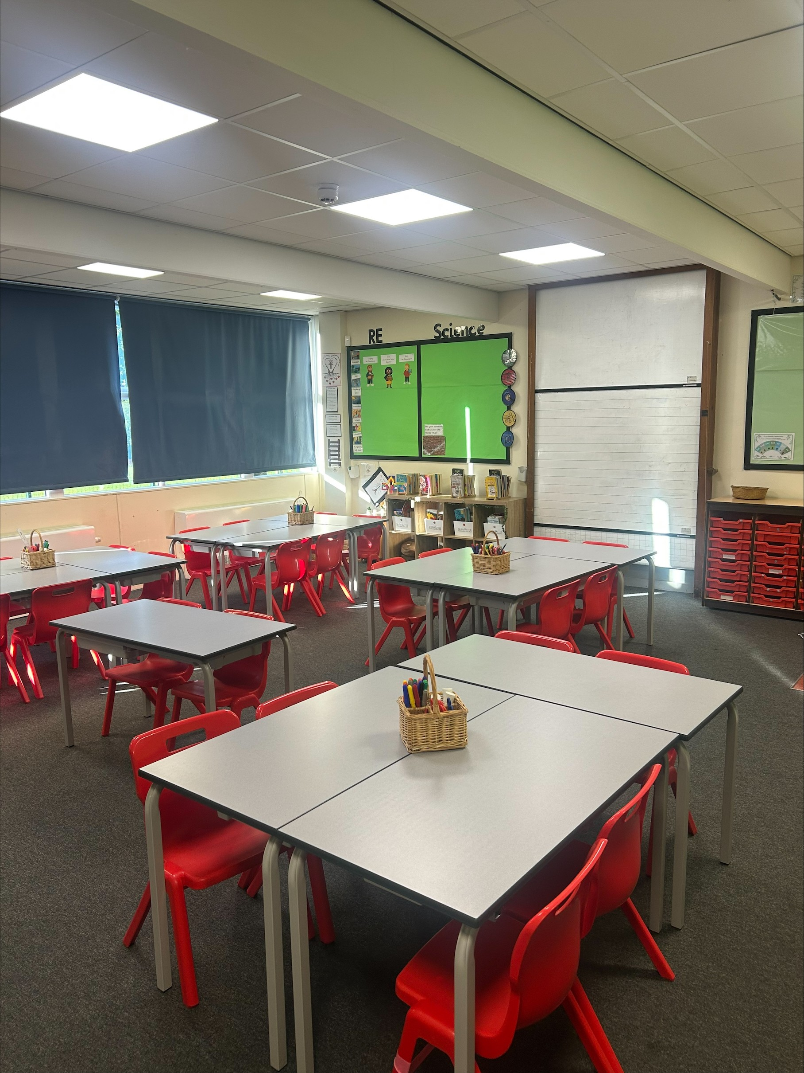

Our topics for this year will be:
Autumn 1 | Autumn 2 | Spring 1 | Spring 2 | Summer 1 | Summer 2
The Ancient Egyptians | The Lake District | The Anglo-Saxons and Scots | Let the Battle Commence- The Vikings | Road Trip USA | Mighty  Mountains
More detailed information can be found on the class page on the school website
Useful Information
Breakfast Club is available from 7.30am –Please ensure children are booked in using School Money app so that staff know who to expect the following day. Younger children need to be handed over to staff at the door to ensure safe arrival as registers are not completed in class until 8.50am
Children need to arrive between 8.45am – 8:50am and need to be supervised by an adult until the doors are opened at 8.45am. Children should only be on the trim trail if an adult is with them.
School finishes at 3.20pm. Please inform family members to park away from Arundel Street as it is dangerous when cars drive down this street at the start/end of the day. For safety, the school car park is only for staff use.
Years 3/4 door leads out to playground and y5/6 directly to classrooms.
Please make sure that someone is here to collect your child on time at 3.20pm as children can become unsettled if they are left waiting.

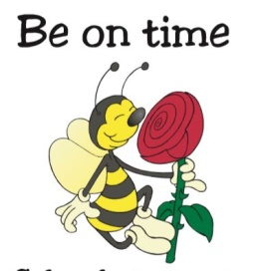

School Holiday Dates 2026-2027
https://www.st-peter-st-pauls.lancs.sch.uk/attachments/documents.asp?id=819

Please do not book holidays in term time as absences cannot be authorised and it means children will have 2 unauthorised absences per day as registration takes place in the morning and afternoon. Penalty notices may apply if the threshold is met.

 | Term Begins | Half Term Holidays | Term Ends
Autumn | 1st September 2026 | 19th October – 30th October (inclusive) | 18th December 2026- 2pm
Spring | 4th January 2027 | 15th February – 19th February 2027 | 25th March 2027  2pm
Summer | 12th April 2026 | 31st May –4th June 2027 | 21st July 2027  2pm

Uniform https://www.st-peter-st-pauls.lancs.sch.uk/uniform/
Please see link for expectations relating to school uniform, jewellery and hairstyles. All clothing needs to be labelled clearly (writing with a permanent pen on labels is fine) to make it easier to return any lost items.
School Bags
Please do not bring any bags other than the red school reading book bag which can be easily stored in class.
Waterproof Pants and Wellingtons
We encourage all children to have a pair of waterproof pants and wellingtons (with a small bag to put them in) to keep in school. The children will often take part in outdoor learning activities and wet playtimes.
Earrings
It is better if children do not wear earrings for school but if they choose to please make sure the wear one pair of plain small studs. These need to be removed (at home) for PE (Thursday and Friday in the autumn term) as they cannot be covered over with tape. If having ears pierced, please do this at the start of summer holidays so that PE lessons are not missed.
Water Bottles
Please send in a water bottle with a sports top rather than a lid that unscrews. As we are a Healthy School, children are only allowed to drink plain water during lesson time (juice or flavoured water are only allowed in lunch boxes). Water bottles will be sent home each day so that they can be washed out and refilled.

School Lunches https://www.st-peter-st-pauls.lancs.sch.uk/school-lunches/
The cost of school dinners is currently £3 per day which should be paid on School Money at the time of booking so that meal choices can also be made.
Snack
Children are only allowed to bring a piece of fruit for morning snack.
Reading Books
Please ensure these are in bags on the days we change which are Mondays and Thursdays. It is very important that children practise their reading skills at home by reading to an adult on a regular basis. This should include asking children about what they have read to develop their comprehension skills. Ideally, this needs to be for a few minutes each day. Please sign reading records to show that your child has read and when the book has been finished and is ready for changing.
Homework
Homework booklets are given out at the start at each half term and are also available on the website under our class section. It includes a weekly spelling challenge which will identify a particular spelling pattern/skill to learn each week. This will be introduced to the children in class on a Monday. It also includes a short Maths activity that fits in with what we have been doing in class that week.
Mobile Phones
Children are not allowed phones in school unless walking home alone and parents are required to complete a permission form requesting this.
Our PE days are Thursday and Friday (Autumn Term)
Pupils will need a full PE kit in school at all times – black shorts (not cycling shorts), white t-shirt and pumps. Children will bring home kits at the end of each half term to be washed. It is important that these are returned to school so that children are appropriately dressed for the lesson.
Class Trip
We will be planning to take the children out of school later in the year and will provide information on this. We will set up payment on the online system in advance in case you want to pay instalments.
Swimming Lessons
All children in KS2 go swimming throughout the year and information will be provided for you in advance. Year 4 will be swimming first in the Autumn term. Children need to have a swimming costume, fitted trunks and a swimming hat if you want to get these in advance. Children need to be in school by 8.50am on swimming days.
Website
Please see our class section of the website for photos and more information on our learning. We also have a Facebook page which provides lots of information about life at school.
St Peter and St Paul's Church of England Primary School - Class Pages
Superstar Celebration
This will take place every Friday morning (from 11th Sept) and parents are welcome to attend. A Superstar certificate is awarded to one child from each class and children can bring in certificates and awards from meaningful activities completed out of school hours. Each month a ‘megastar’ certificate is awarded in each class to someone who consistently goes above and beyond.
Breakfast Club and After School Club
Our wrap around care is from 7.30am until 5.45pm and children need to be booked in using School Money to be allocated a place. The after-school club needs to close promptly at 5.45pm and children must be collected by this time to avoid having to pay a late collection charge.
All bookings need to be made in advance using the online payment system and unfortunately, due to numbers having increased significantly, there is a chance your child may not have a place if they are not booked in as we must ensure we have the appropriate staffing in place. Places cannot be reserved online on the day and you will need to ring school to check if space.

Behaviour and Positive Recognition
In school, we encourage everybody to behave in ‘The St Peter and St Paul’s Way’, with our school code of conduct being firmly based on our core Christian values.
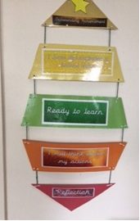
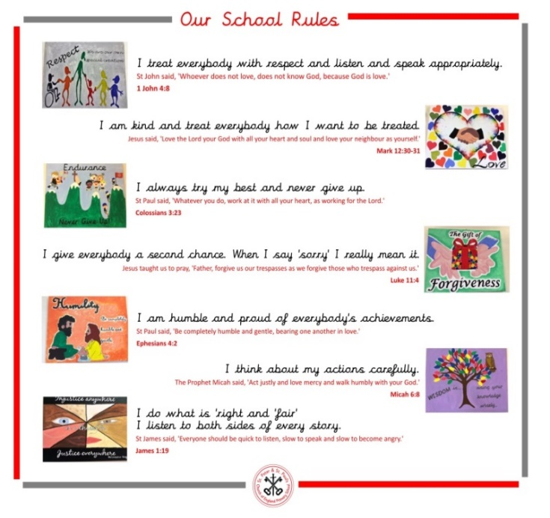

Wherever possible, children are praised for behaving well and where possible this is often by positive verbal recognition. A project we were involved with involving other schools/surveys with our parents highlighted that there is very little value to a child when they are rewarded for doing things which are the ‘norm’ or ‘generally expected’ and that instant verbal praise is the most effective reward for children as it has far more meaning to them at the time.
We have a behaviour ladder (as above) and children’s names all start on green ‘ready to learn’ at the start of each day. Children may be asked to move their name up/down the ladder. If children repeatedly behave in a negative manner after several reminders and have moved their name, they may be asked to spend time in 'Reflection' during their break time. If this happens on several occasions, parents will be notified and children may end up missing out on some of the additional fun aspects of school.
We also use a system linked to learning powers where we choose a specific ‘success criteria’ to work on each week. These are based on: making connections and having curiosity, changing and learning, building resilience, having strategic awareness, creativity and learning relationships. The intention is that each child will add their name to the wall of recognition by the end of the week for achieving one of the learning powers and that collectively as a class they can all achieve this. We have seen the pleasure the class get from this accomplishment and that they all try to encourage each other and recognise when individuals have demonstrated the learning power.
There are 3 learning powers:
Tortoise Teamwork
Resilient Rabbit
Independent Insect

Year 4 Times Table Check
The multiplication times table check (MTC) is a statutory assessment for all Year 4 children in England which takes place in June. The purpose of the check is to determine whether your child can fluently recall their times tables up to 12x.
More information about the check can be found on:
Multiplication tables check: information for parents - GOV.UK
We practise our times tables daily in class; however it would be useful if you could encourage you child to also practise at home for example by logging into ‘Times Table Rockstars’ or playing ‘Hit the Button’.
Home - Times Tables Rock Stars
Hit the Button - Quick fire maths practise for 6-11 year olds - Topmarks

As the year goes on we will be practising the test using MTC - Multiplication Tables Check - URBrainy.com and this can also be practised at home.

We look forward to working with you and your family this year!

