 | Autumn 1 | Autumn 2 | Spring 1 | Spring 2 | Summer 1 | Summer 2
Topic | 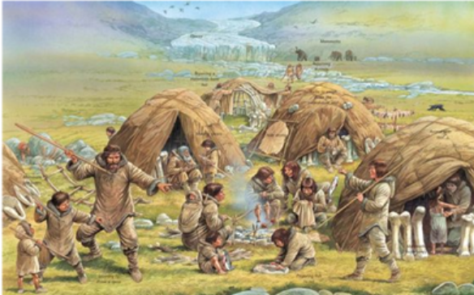  Prehistoric Britain
Reading links | The Stone Age to Iron Age Topic Booklist - Best Children's Books
Local area links

Topic Website Links | Prehistoric - Year 3 History - BBC Bitesize  Skara Brae facts for kids | National Geographic Kids
General Websites to support learning | Times Tables Rockstars https://ttrockstars.com/ (Log in details can be found in reading logs)  Top Marks https://www.topmarks.co.uk/  Maths Zone https://mathszone.co.uk/  Word of the Day https://vocabularyninja.co.uk/word-of-the-day/  Science websites https://www.st-peter-st-pauls.lancs.sch.uk/page/?title=Website+Links&pid=911  Geography websites https://www.st-peter-st-pauls.lancs.sch.uk/page/?title=Website+Links&pid=928
Information and videos for parents to support learning | https://www.st-peter-st-pauls.lancs.sch.uk/reading-information-and-support-for-parents  https://www.st-peter-st-pauls.lancs.sch.uk/phonics-2  https://www.st-peter-st-pauls.lancs.sch.uk/information-for-parents-about-the-maths-curriculum

